**Analysis document**

**Group 03**

**Phase 01**

This phase consists of staging the dataset and doing the required transformation, along with creation of dimensional model. We created a staging table and for further transformations we created a landing table.  
  
Dimension Model before the change request  
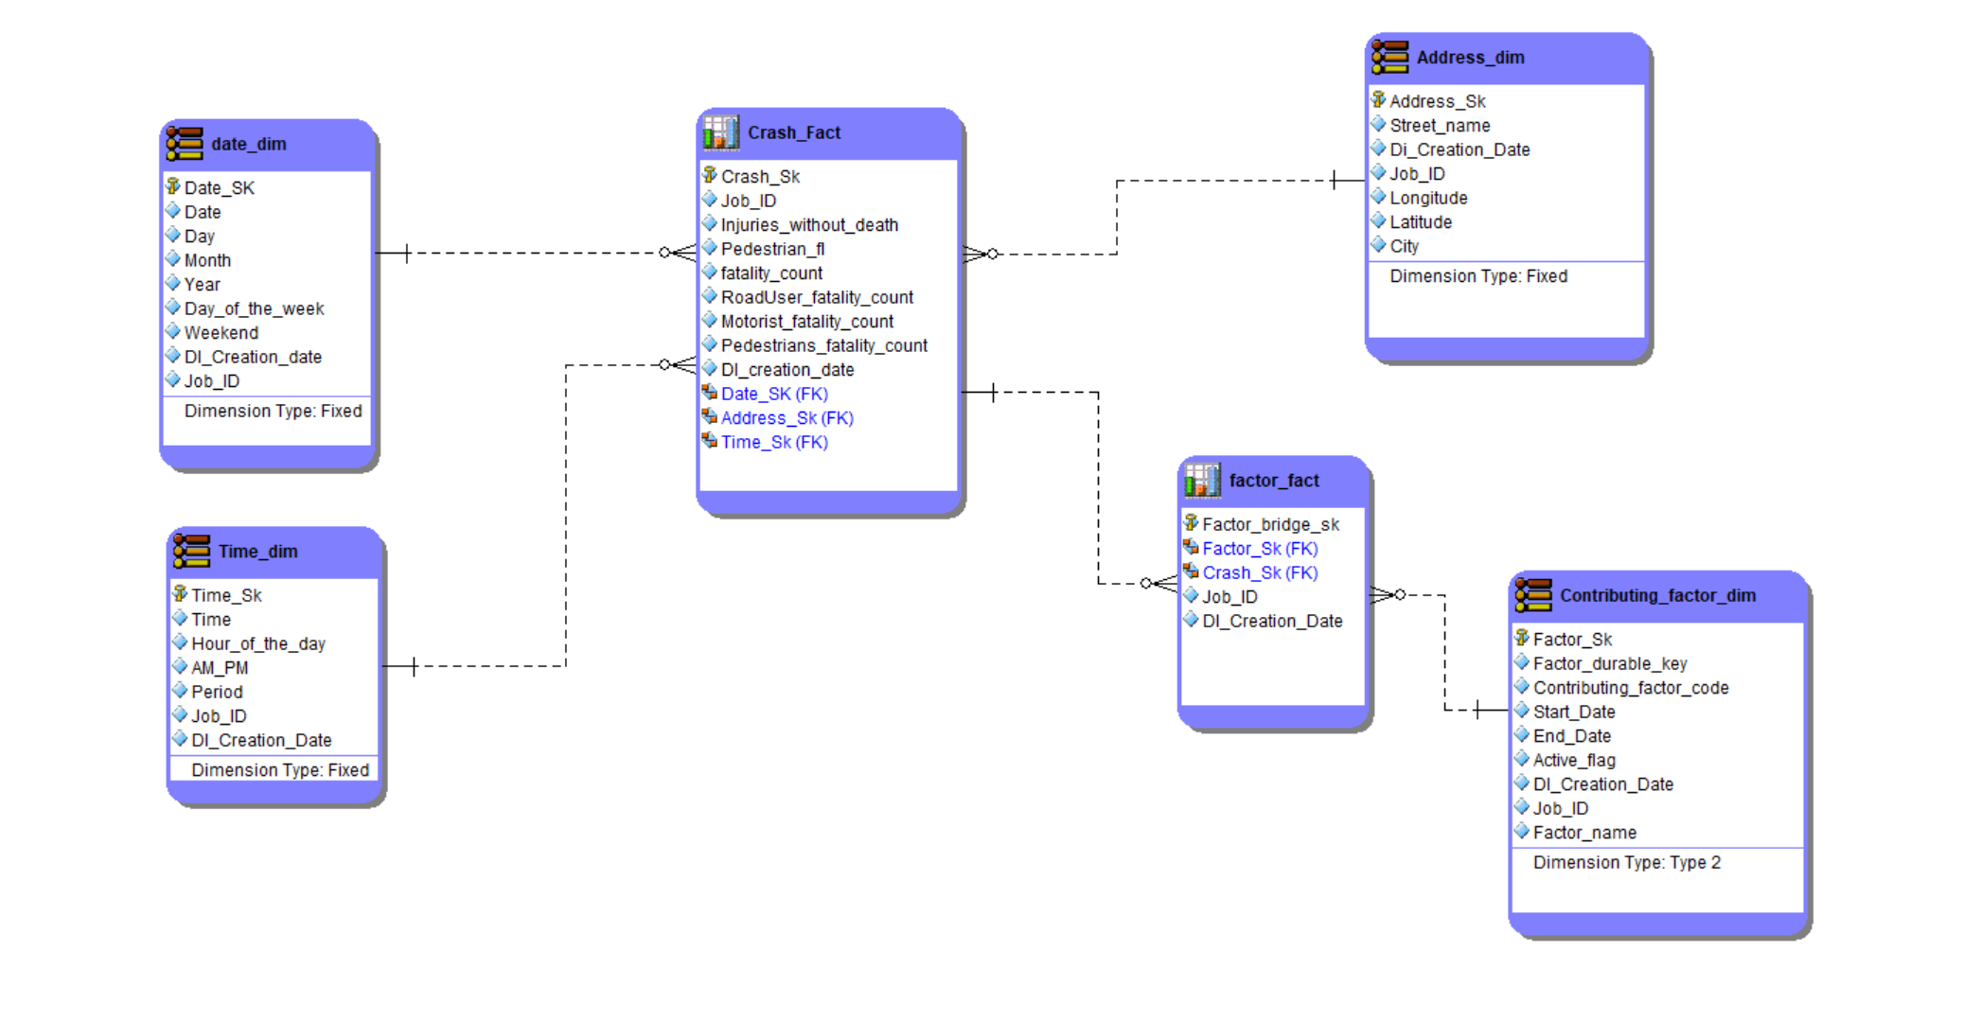  
Dimension Model after the change request  
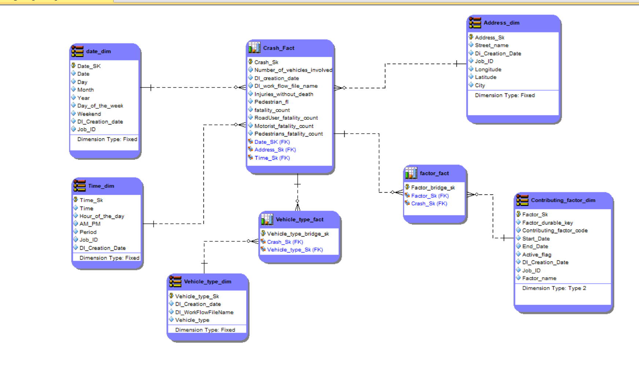

**Austin**  
**Staging Job workflow**

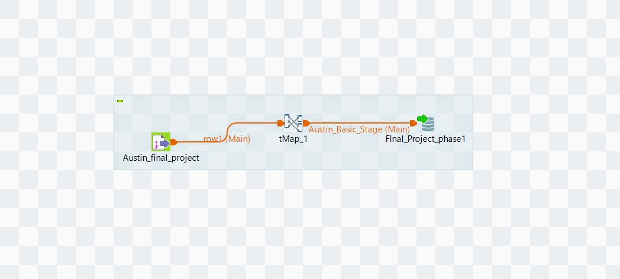

The above is the Austin staging workflow where we took the input as a file delimited and mapped all the columns using tmap and connected the output of t-map with a dboutput component which writes the data in “Stg_Austin” table.

**T-Map configuration**

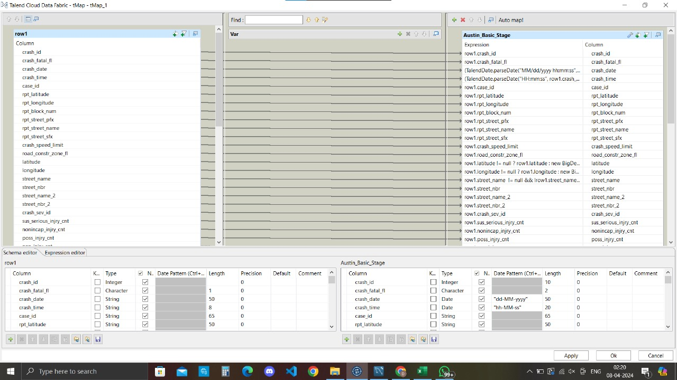

Here we parsed the crash_date, crash_time from string to date format using one of the talendDate functions, handled null values in longitude and latitude by putting 0 where null values are present, same was done for street_name where null values were replaced by the string “Not Given”.

**Chicago  
Staging Workflow**

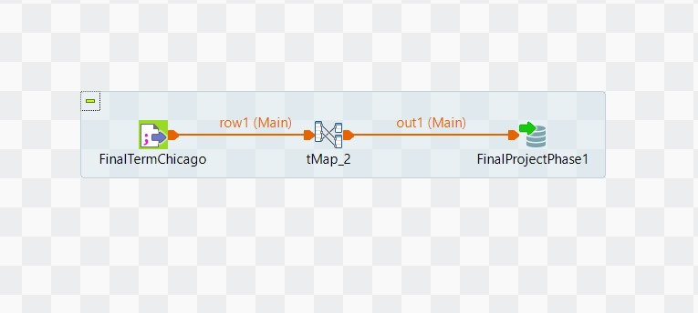

**T-map configuration**

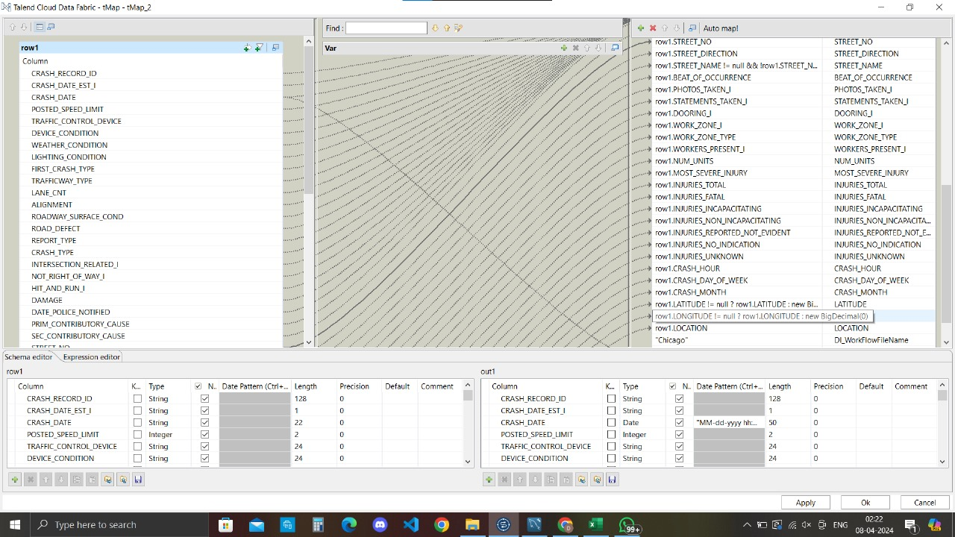  
Here we have converted CRASH_DATE from string to date using parsedate and extracted just the date part in CRASH_DATE, also created and Crash_Time column and extracted the time from CRASH_DATE and stored it in Crash_Time. Handled null values in LONGITUDE and LATITUDE by replacing the null values with 0 and handled STREET_NAME by replacing the null values with “Not Given”.

**New York**

**Staging workflow**

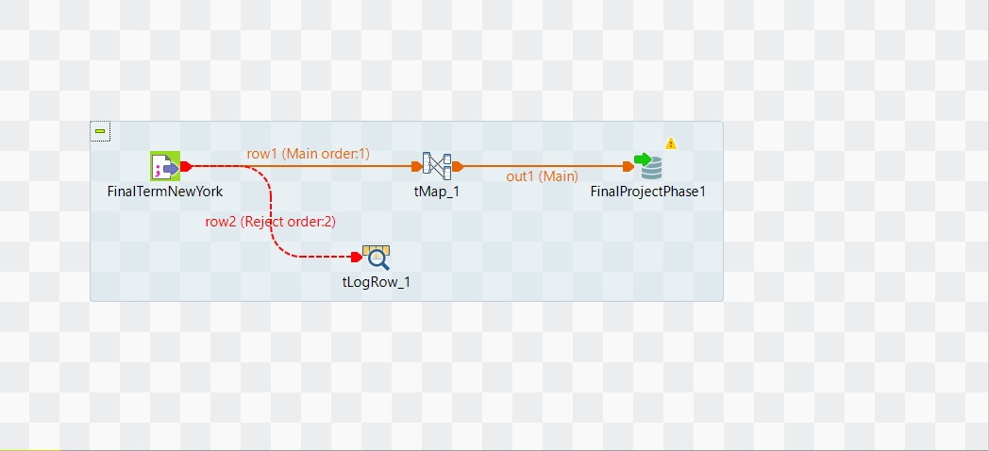Here there was one reject row for the column NUMBER_OF_PERSONS_INJURED, here there was an unparsable string value “Unspecified”.

**T-map configuration**

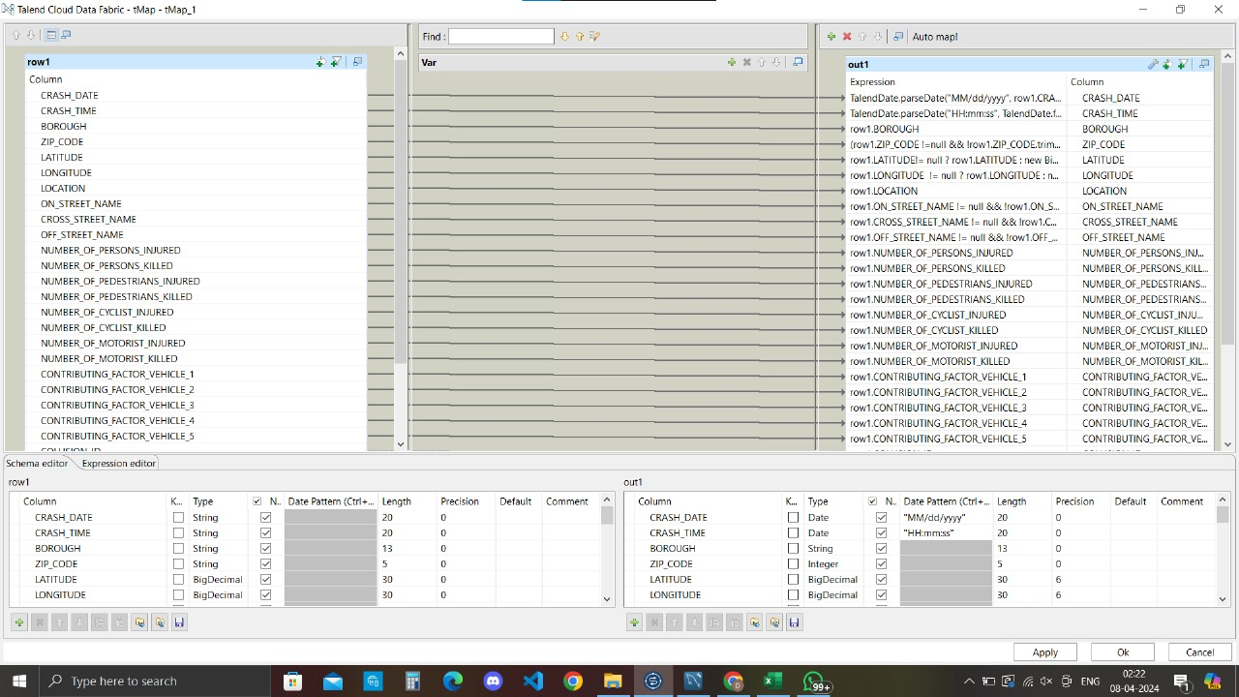

Here we converted CRASH_DATE AND CRASH_TIME from string to date time using parsedate function, handled null values for LATITUDE, LONGITUDE by replacing the null values with 0, handled null values for ON_STREET_NAME by replacing the null values with “Not Given”.

**Landing table of Austin**

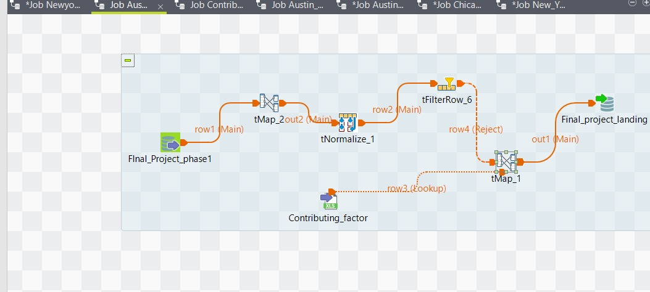

Here we have taken the input of the staged table of Austin and then combined the contrib_factr_p1_id and contrib_factr_p2_id to a single column Contributing_factor_code, and brought the crash_id. We then normalized it and the took unique rows using tfilter row. Bought in the contributing_factor_maping xls file as a lookup did an inner join on code and combined the Description and contributing factor description of Austin.

**T-map configuration**

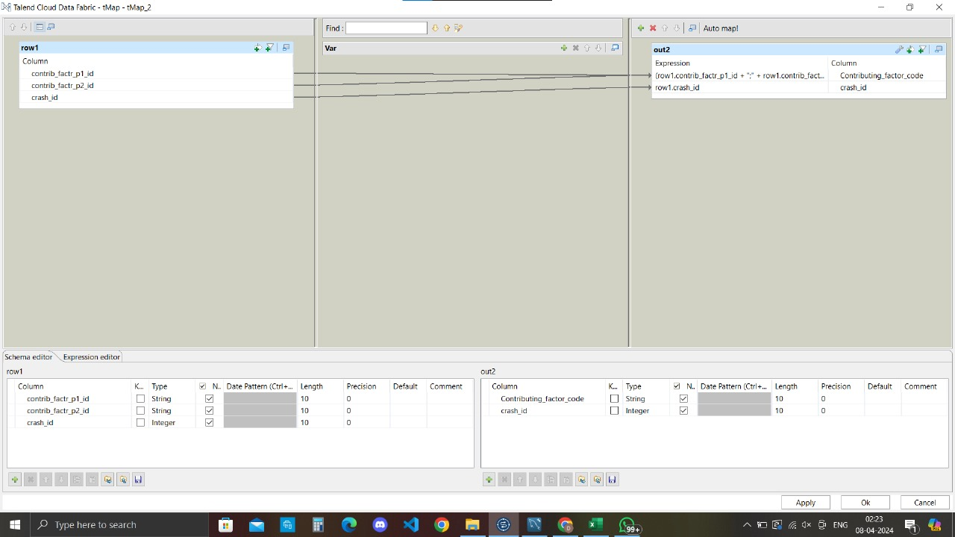

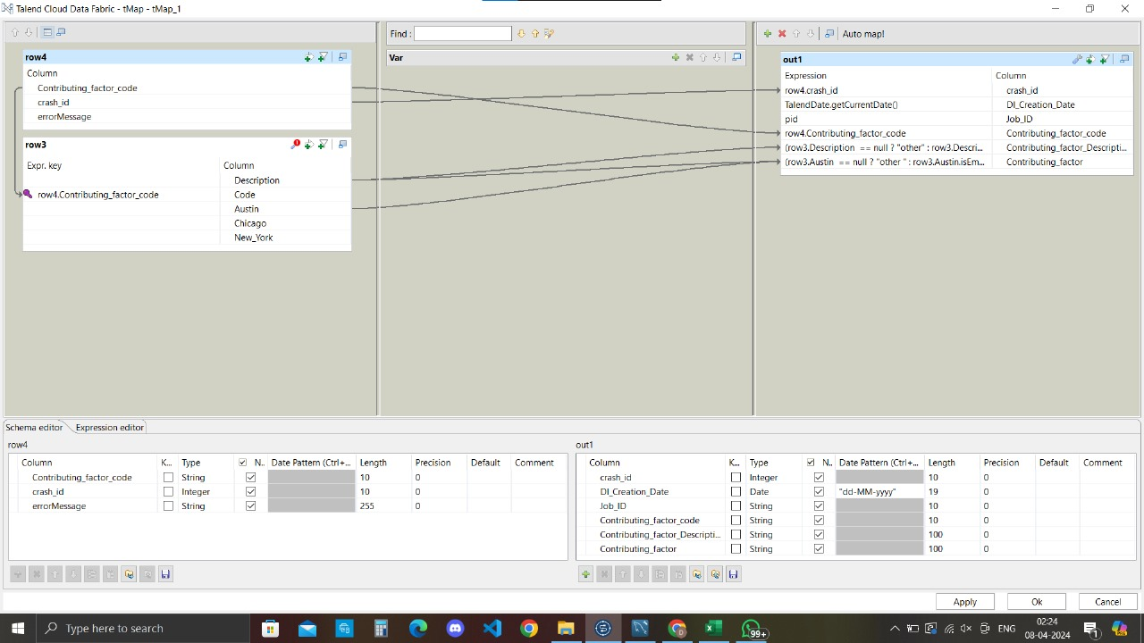

Also handled null values in Contributing_factor_code by putting “other ” in place of null values and same with Contributing_factor.

**Chicago landing table   
Workflow**

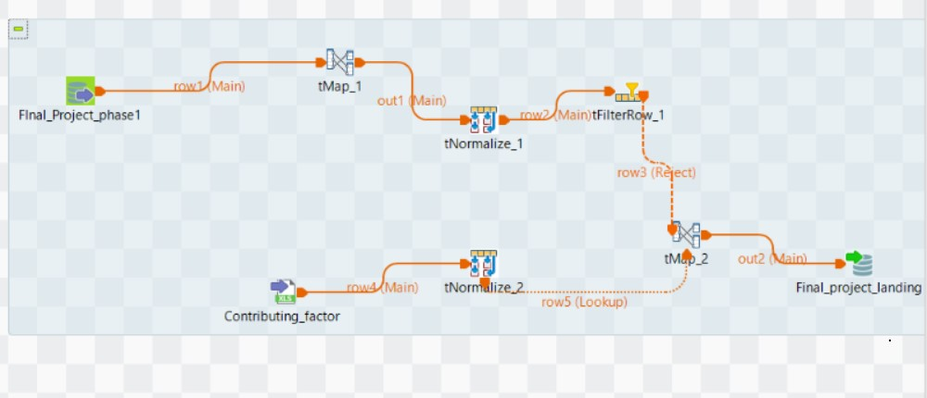

**T-Map configuration**

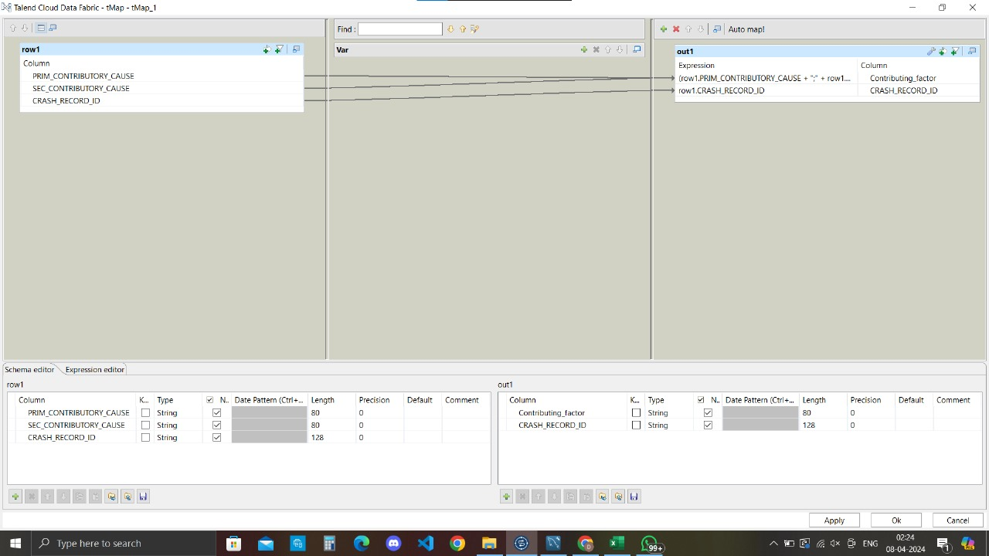

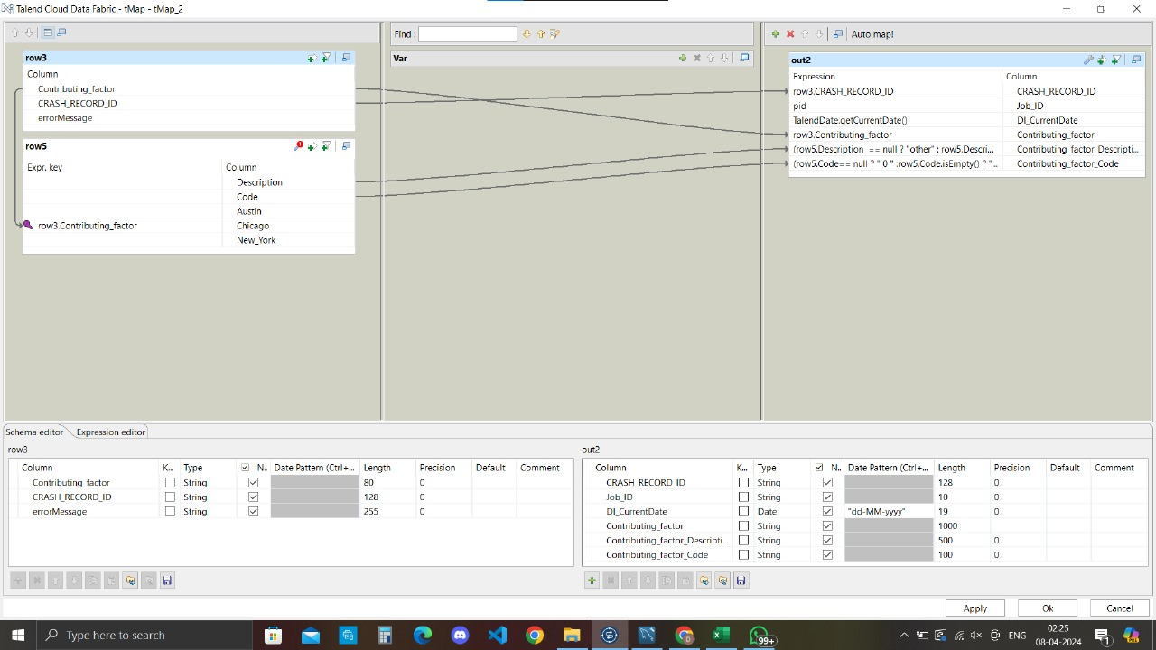

Here we are doing a similar join but on Contributing_factor with that of the Contributing_factor of contributing mapping column document.

**New York Landing  
Workflow**

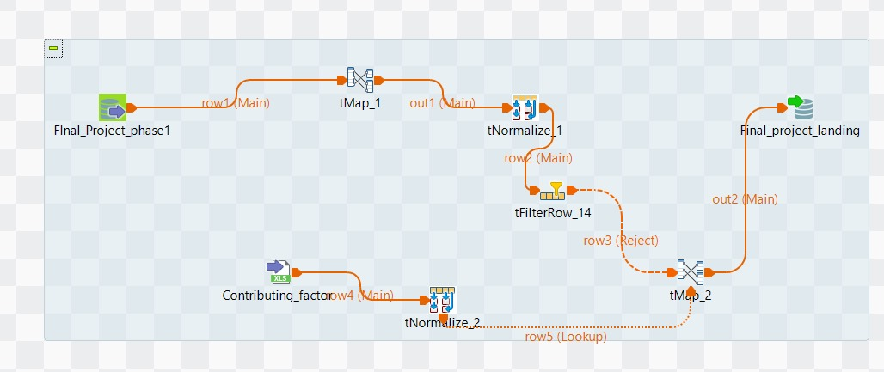

**T-Map configuration**

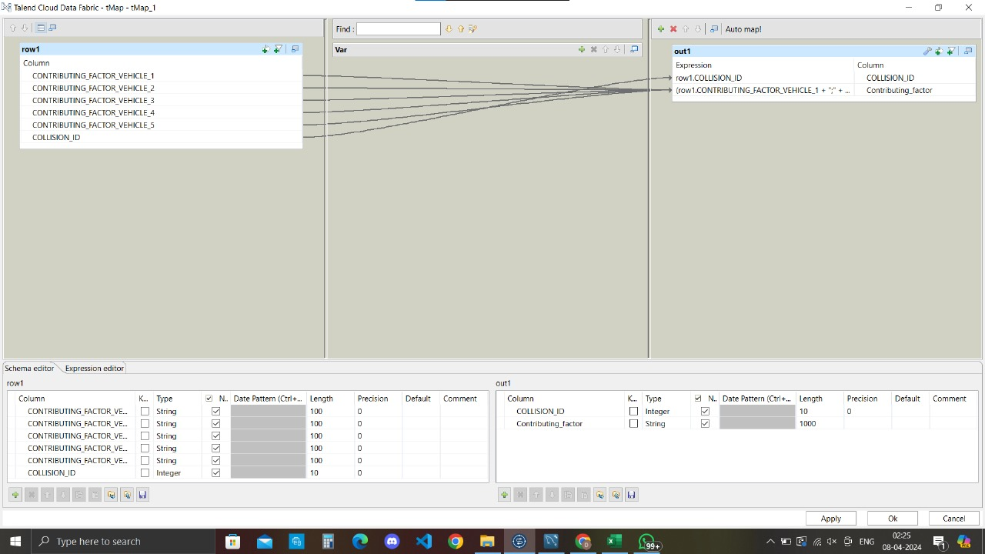

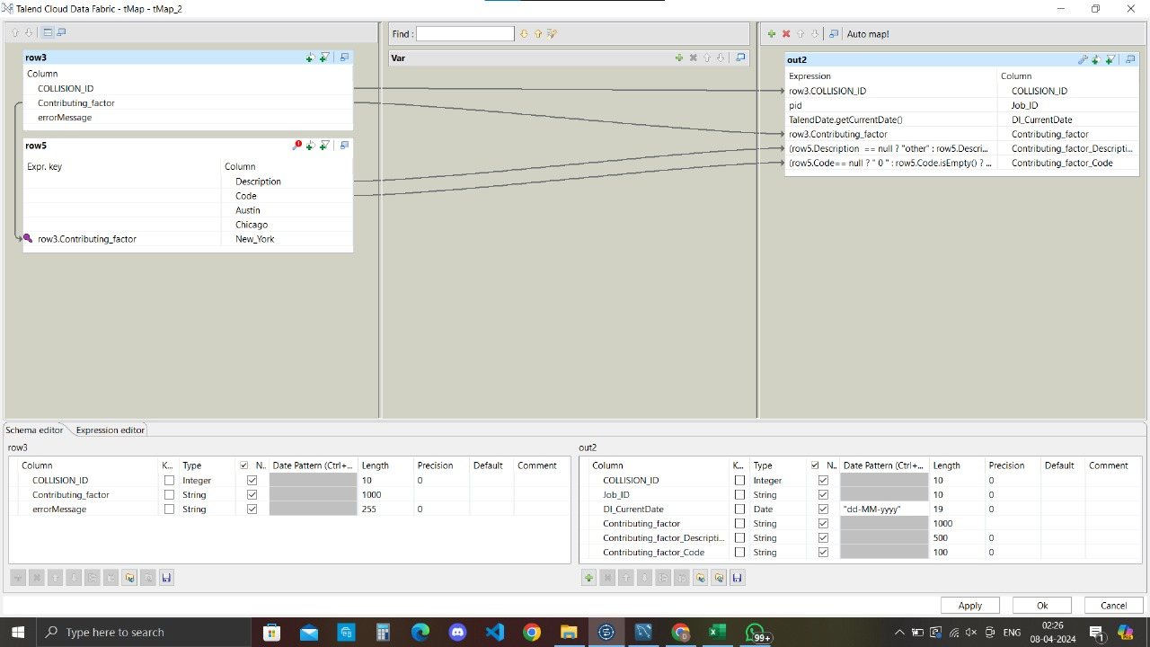

Here we have done the a similar thing as that of Chicago, and mapped the contributing factors, description and code.

**Austin Address Dim**

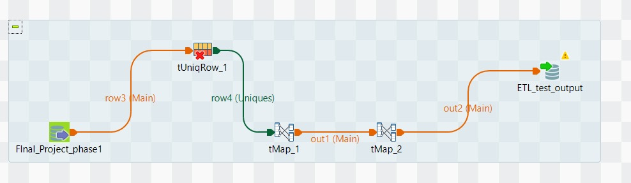

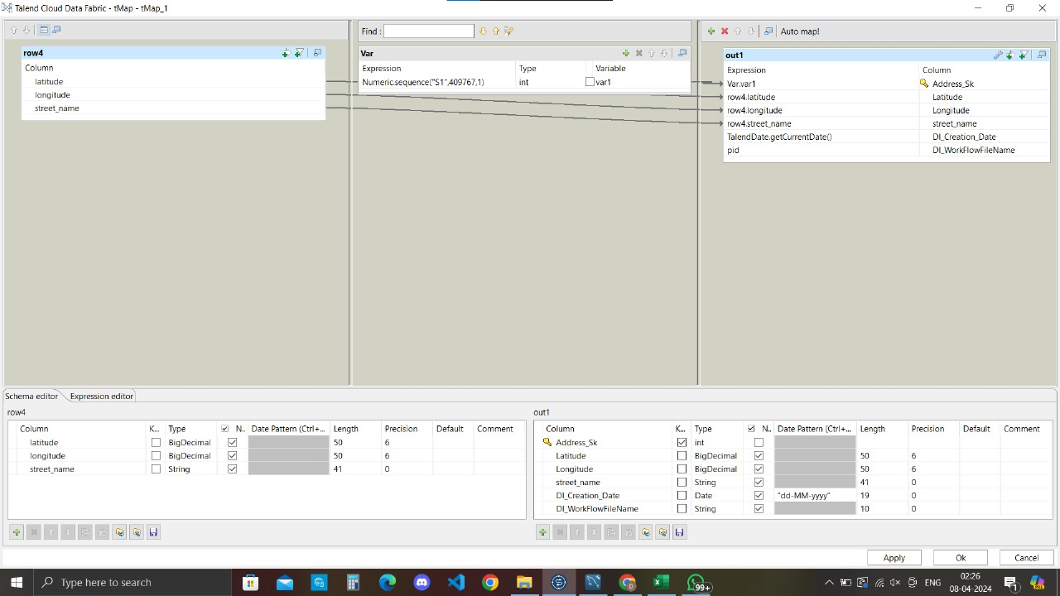

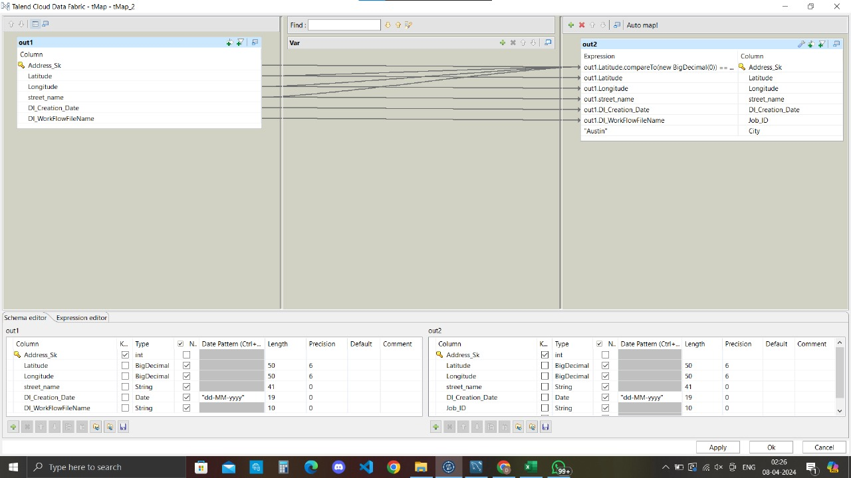

Here we have created a Address_sk as a numeric sequence surrogate key. Comparing the Longitude, latitude and street_name wherever these are null we assign -1 to Address_sk.

**Chicago Address Dim  
Workflow**

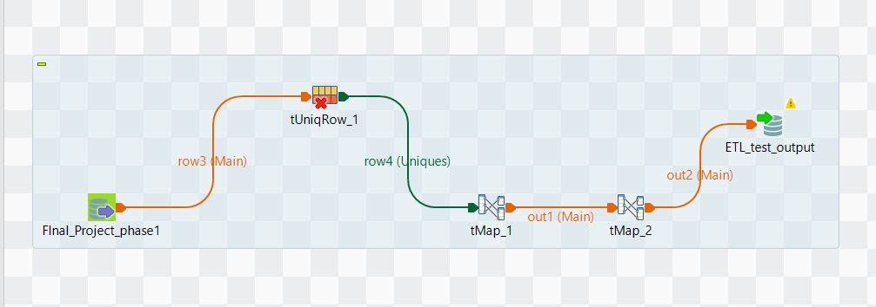 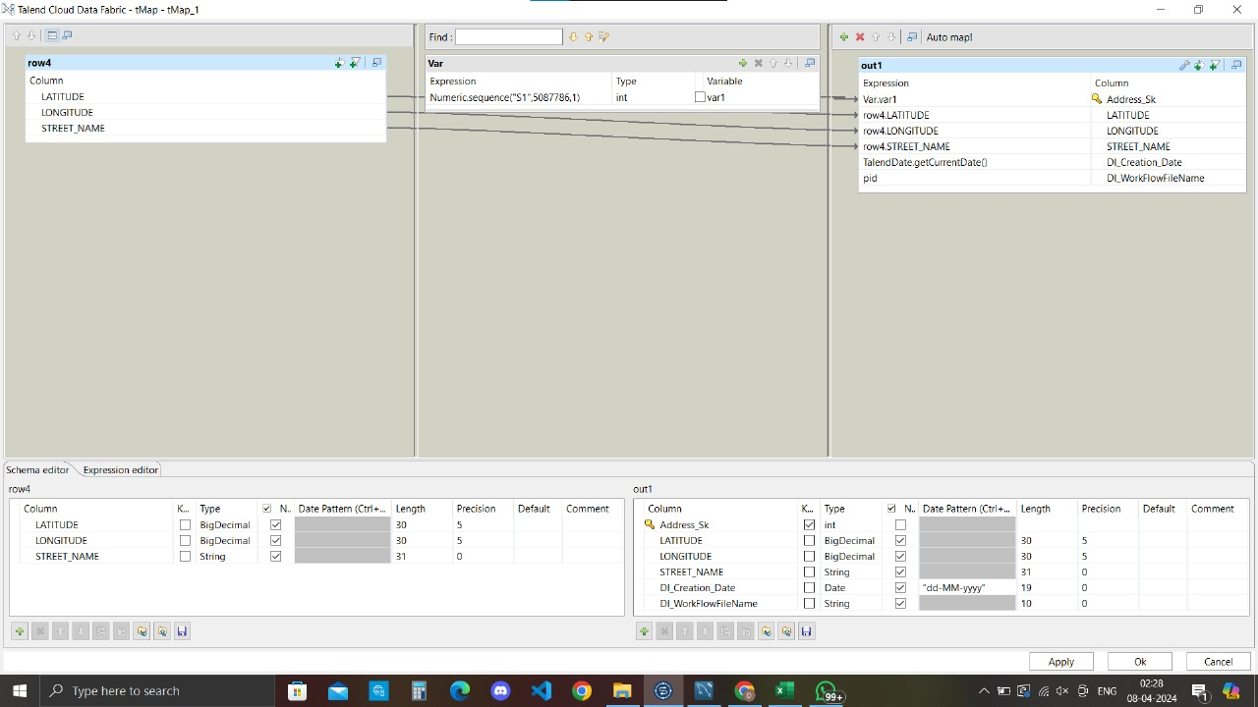

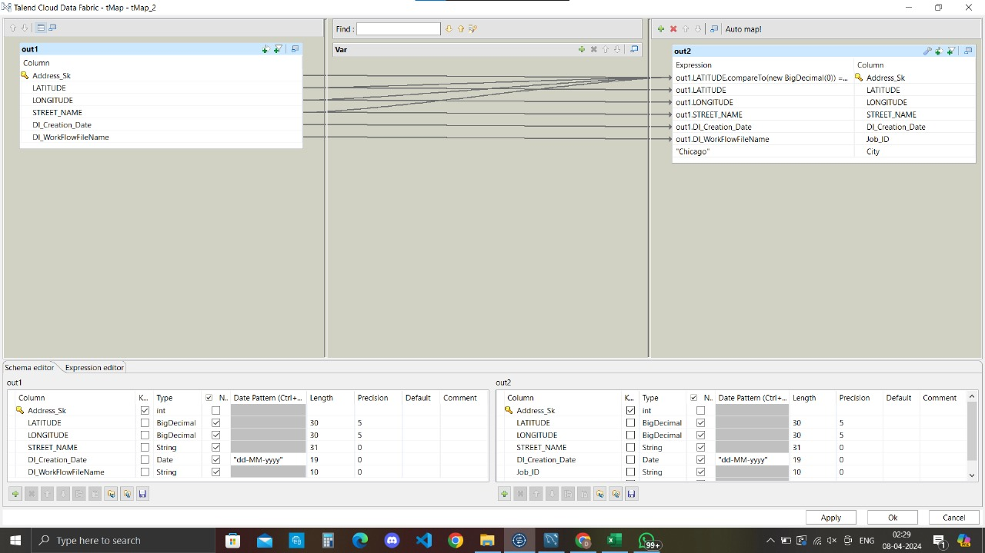

Same is done here for Address_Sk to handle the outlier, but here we are assigning -2 to that row where latitude, longitude and Street name are null.

**New York Address dim  
Workflow**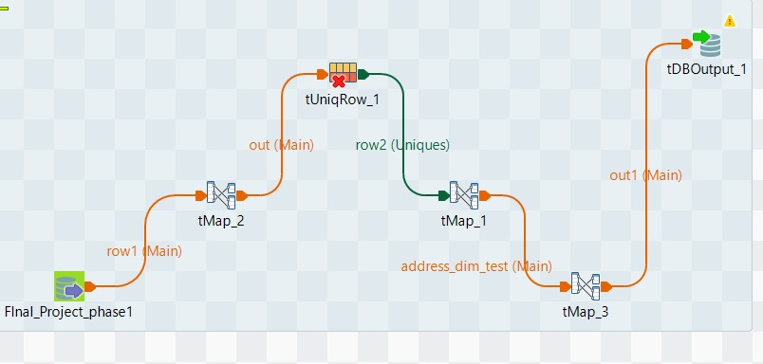

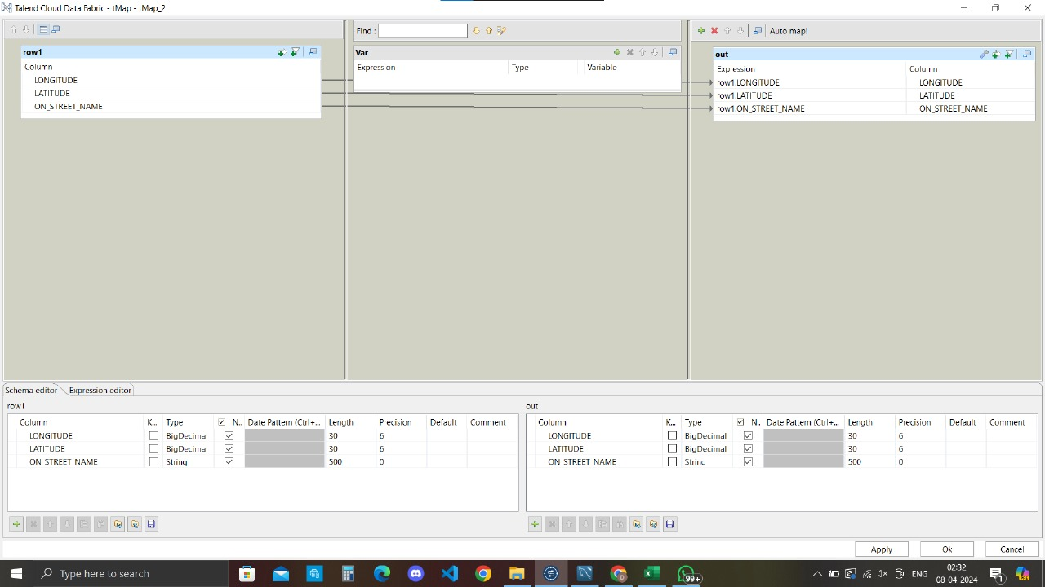

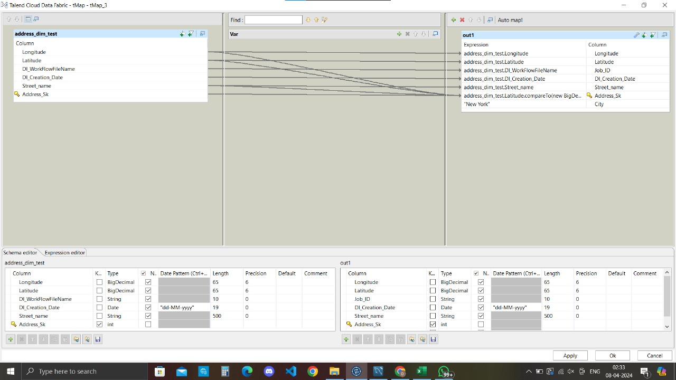

**Contributing Factors Dim  
Workflow**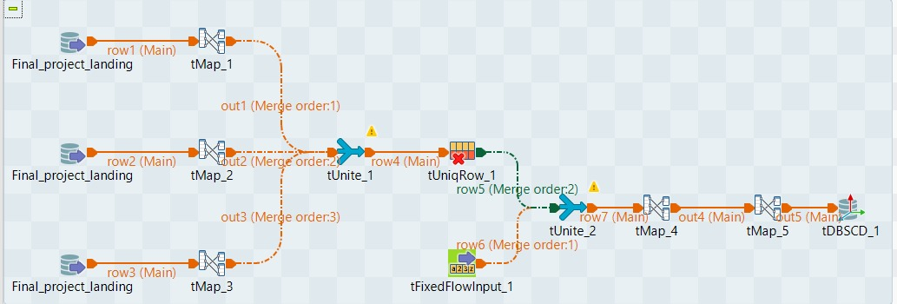

**T-Map configuration**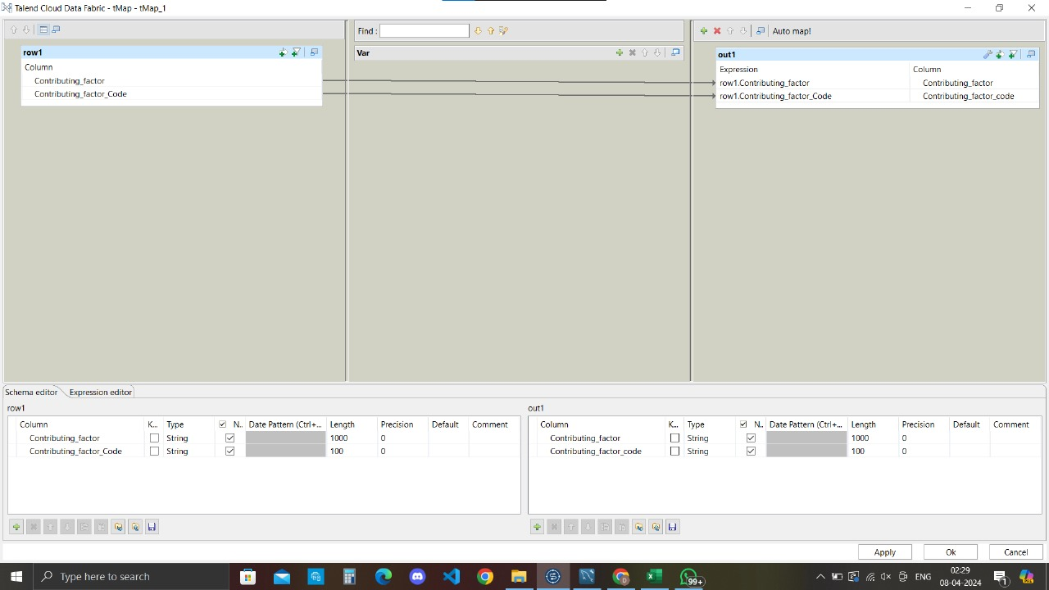

Here we are just mapping the factors and code and passing it through tunique to get unique rows.

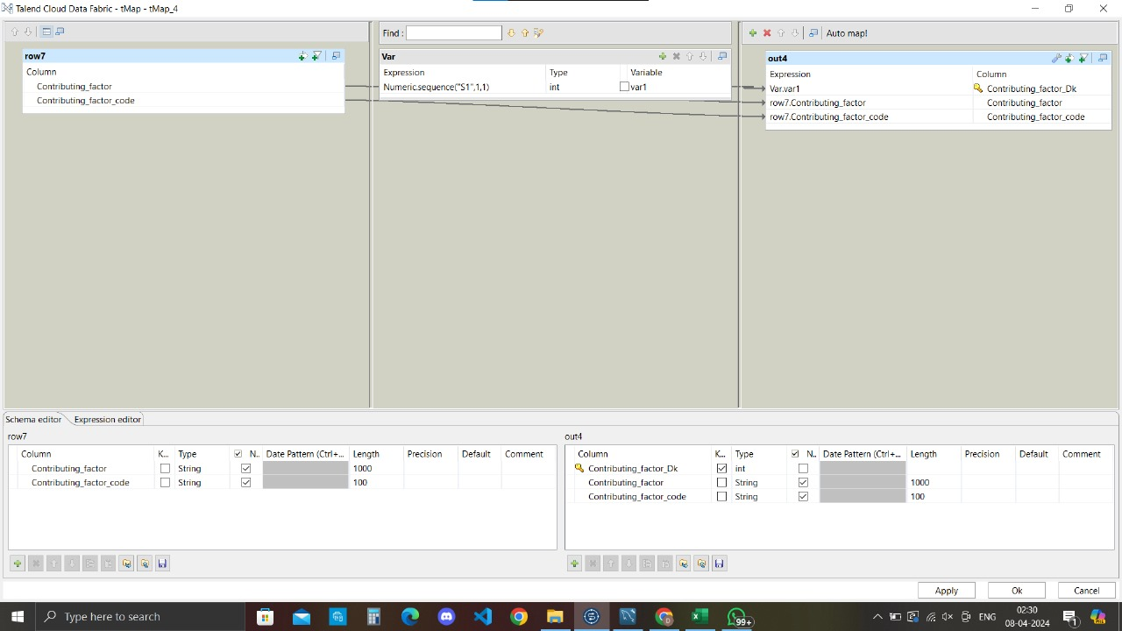

Then we are creating a surrogate key called as Contributing_factor_Sk

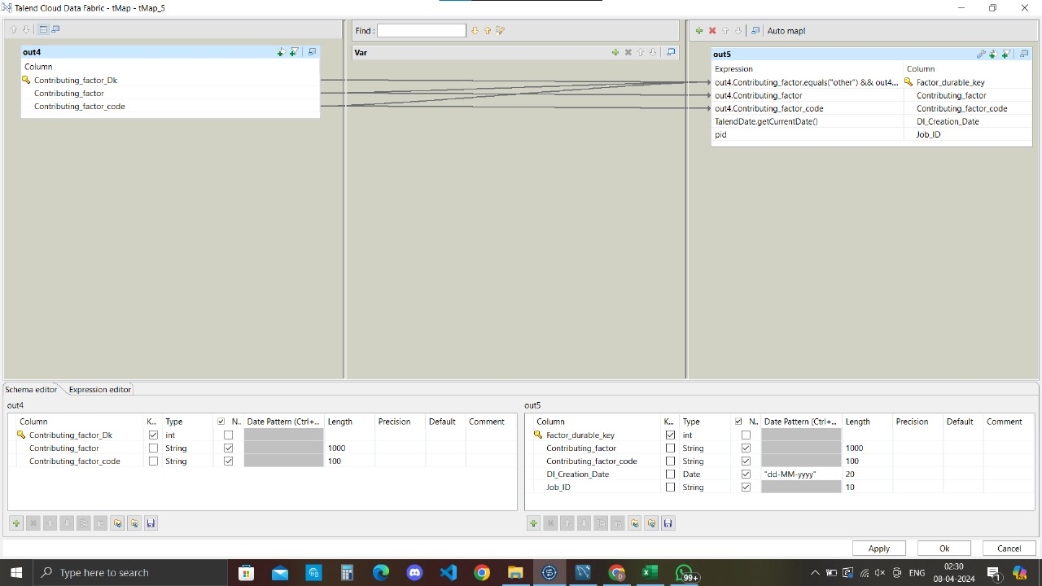

Then created a Factor_durable_key which is a table + 1generated key and having a condition where Contributing_factor and Contributing_factor_code will be null then it will give -1 key.

**Date dimension  
Workflow**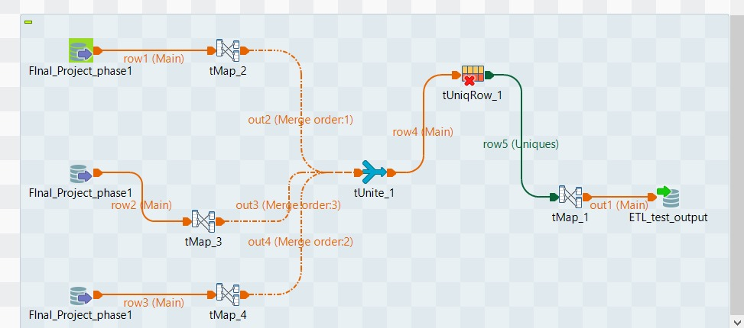

**T-Map configuration**

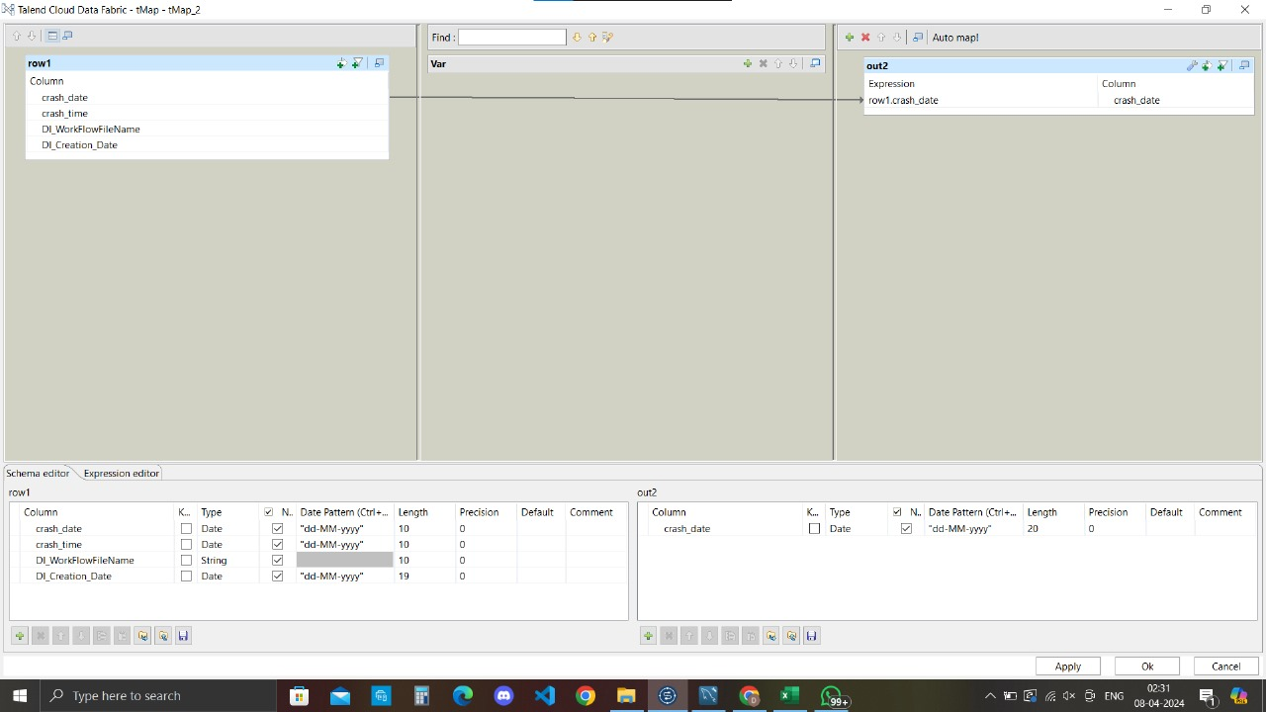

Here we have taken date from crash_date and extracted it to its dd-mm-yyyy format.

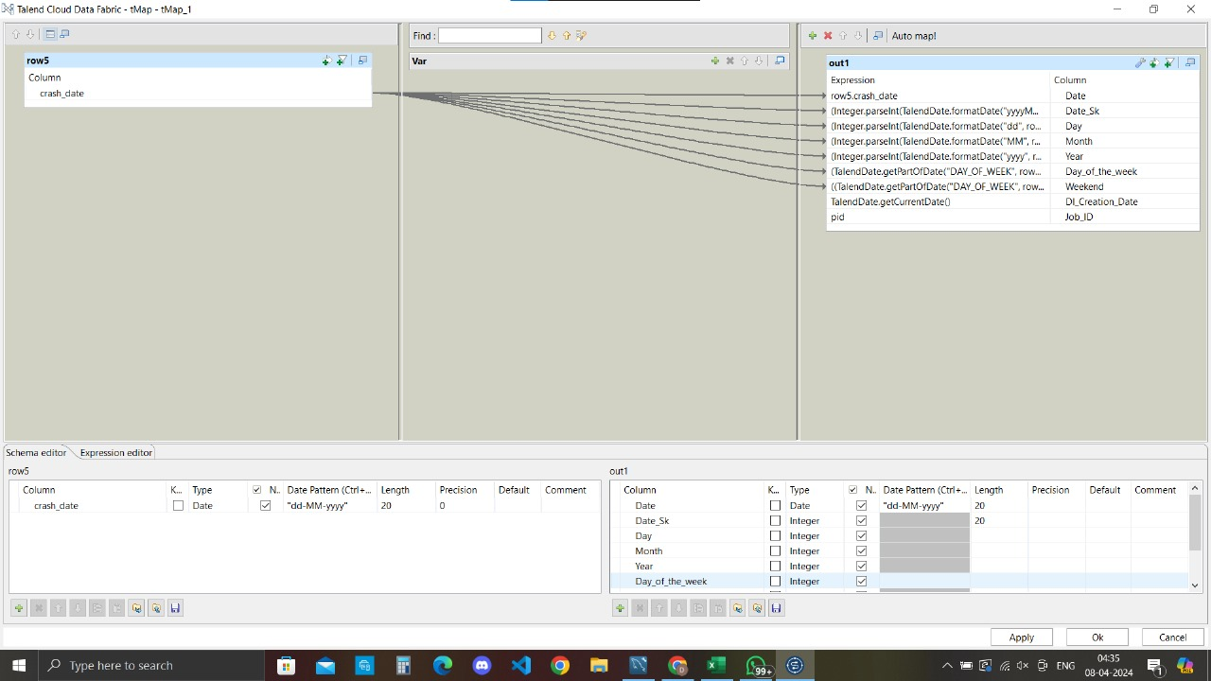

Then we have extracted the date and converted it to string and then to int format which forms our Date_Sk, from the date we extracted Day, month, year, Day of the week, weekend.

**Time Dimension**

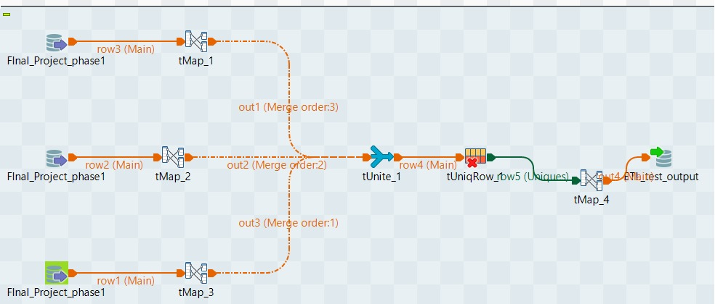

**T-Map**

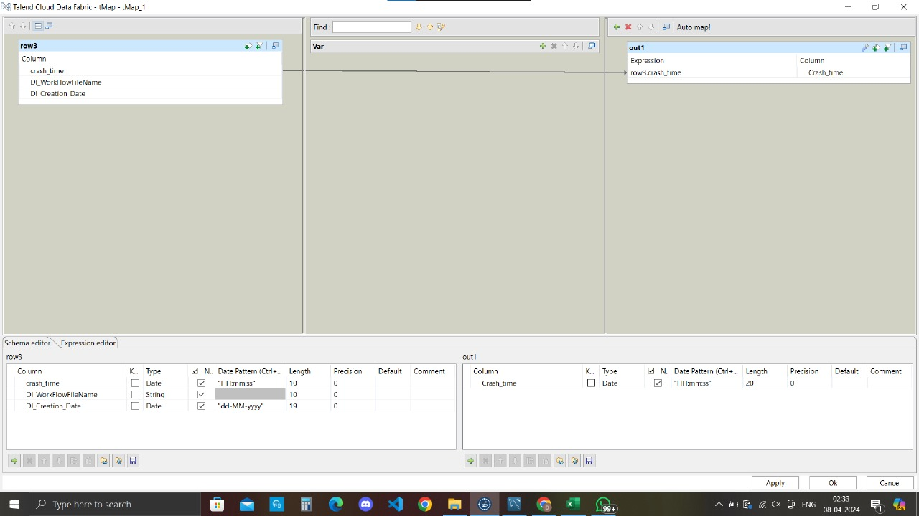

First mapped out time from all the cities

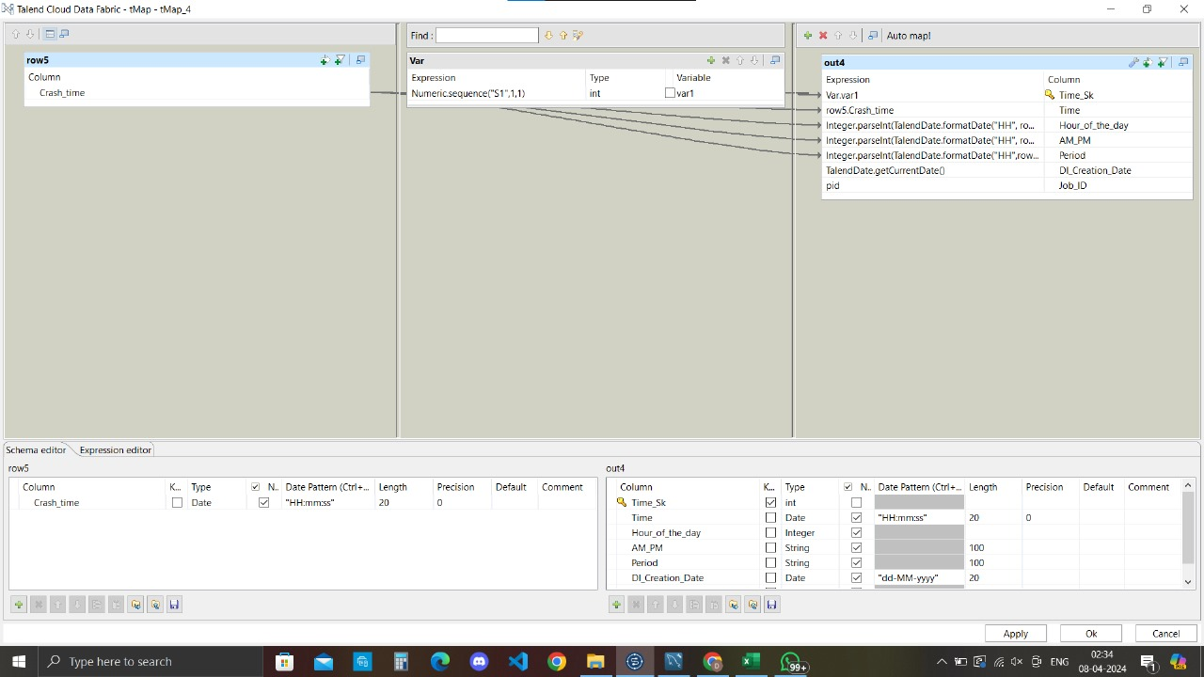

Generated a surrogate key using numeric sequence, but before generating a numeric sequence, we filtered out unique rows and then mapped it back to the tmap where we generated the surrogate key and extracted hour of the day, AM_PM, period and time using basic regx of talendDate.

**Vehicale_type_landing**

**Workflow**

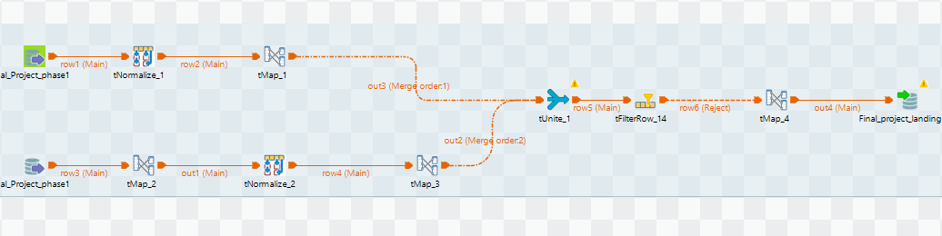

In the above workflow we are taking input from new York and Austin stage as we have to compare the number of incidents that involved two or more vehicles involved between Austin and New York. First we have normalized on the units_involved column with item separator as “&” for Austin and for New York we have normalized on the column Vehicle_type with item separator as “;”.

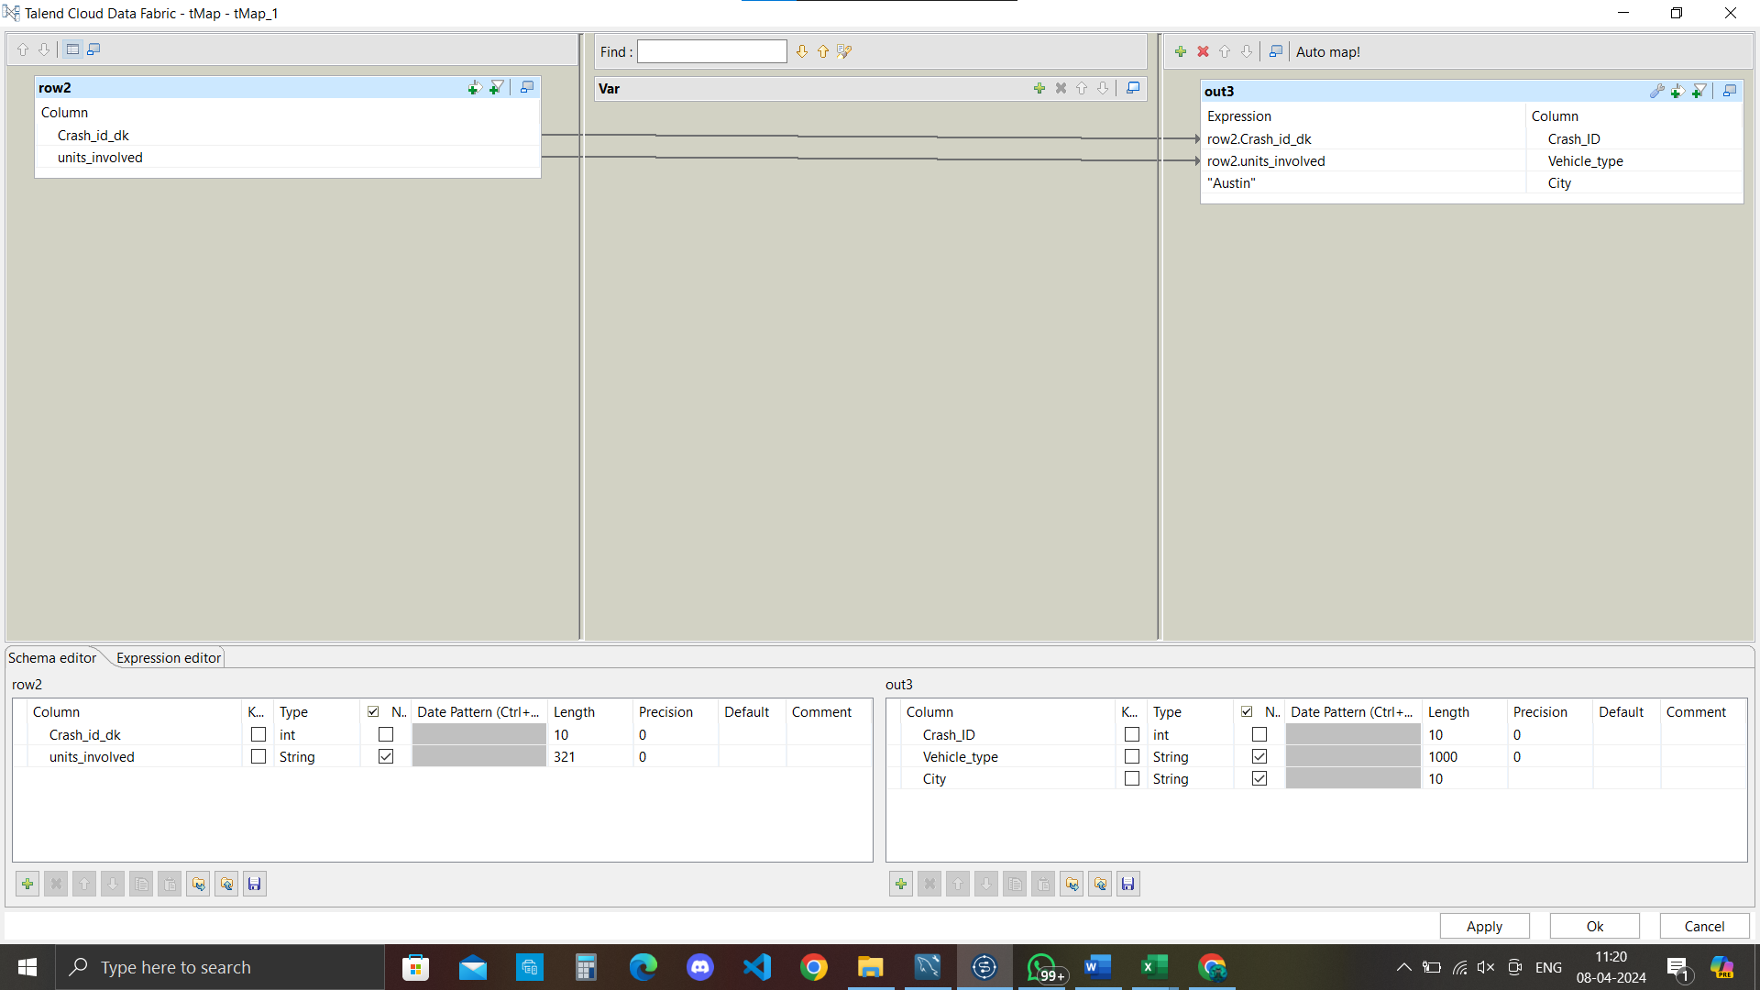

The above is mapping for Austin where the normalized units involved and crash id durable key are mapped with the respective units involved.

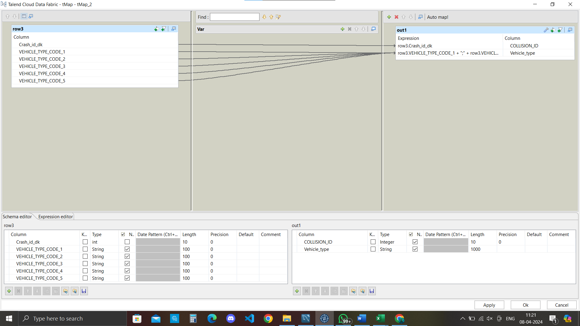

For New York we are combining the rows and storing it in Vehicle_type using the item separator as “;” and then normalizing it on the column Vehicle_type.

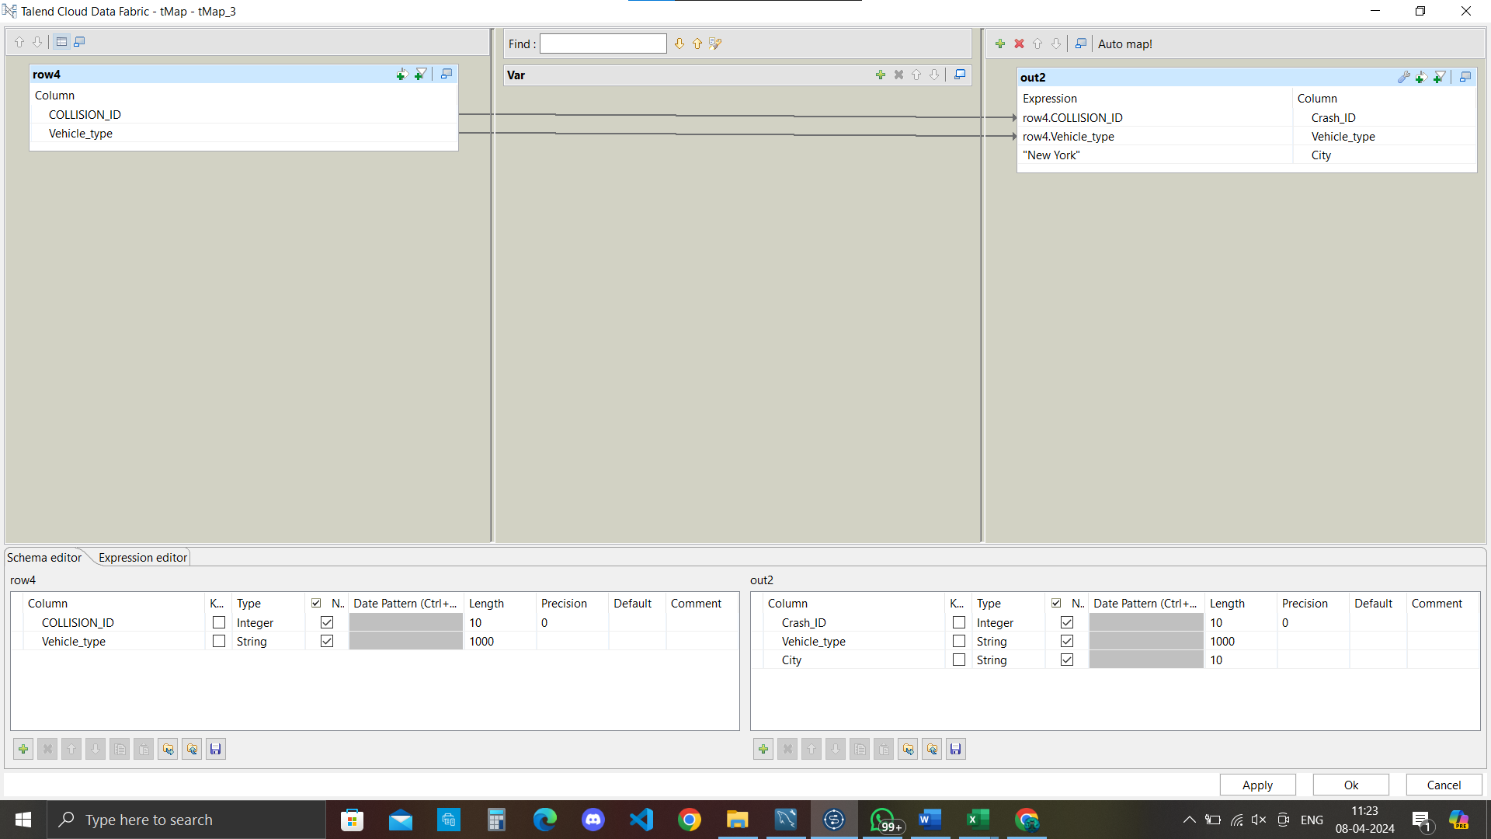

This is then followed by another tmap which is having the above maping. Then we used tunite and then used tfiter row to get filtered output.

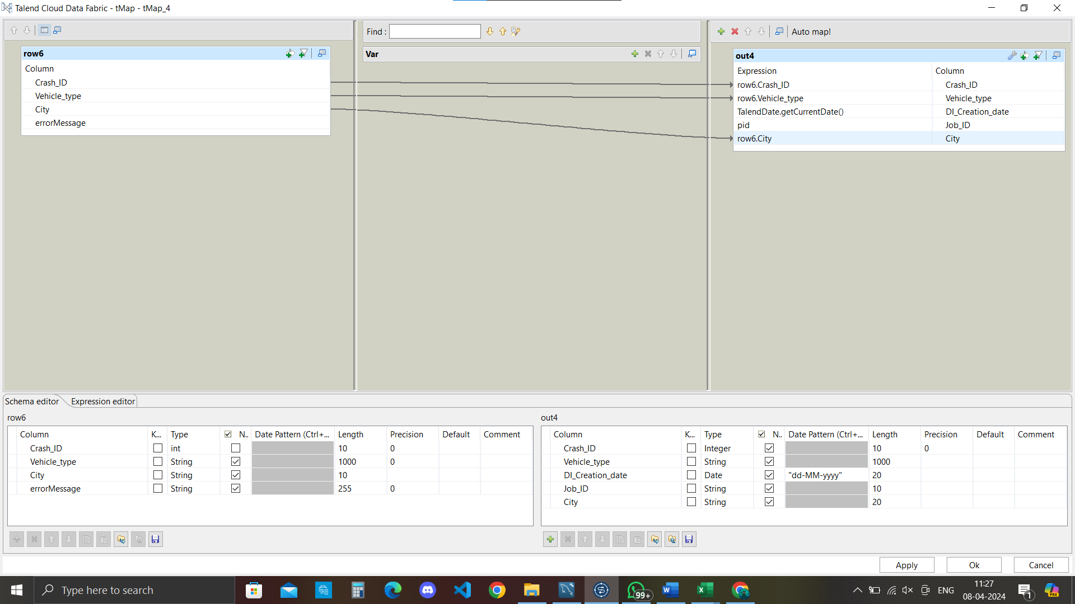

Then it is followed by another tmap with the above tmap configuration.

VehicleTypeCount

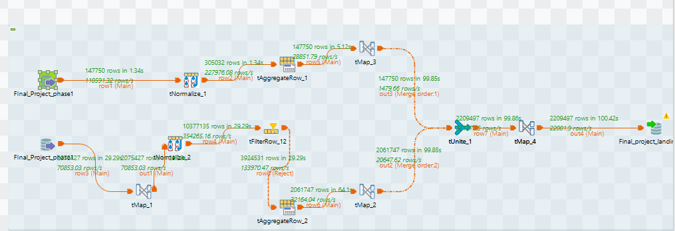

The above is the workflow for getting the vehicle counts.

For Austin we used tnromalizer on the column units_involved with item separator “&” then used taggregaterow, and then mapped with the following tmap configuration:

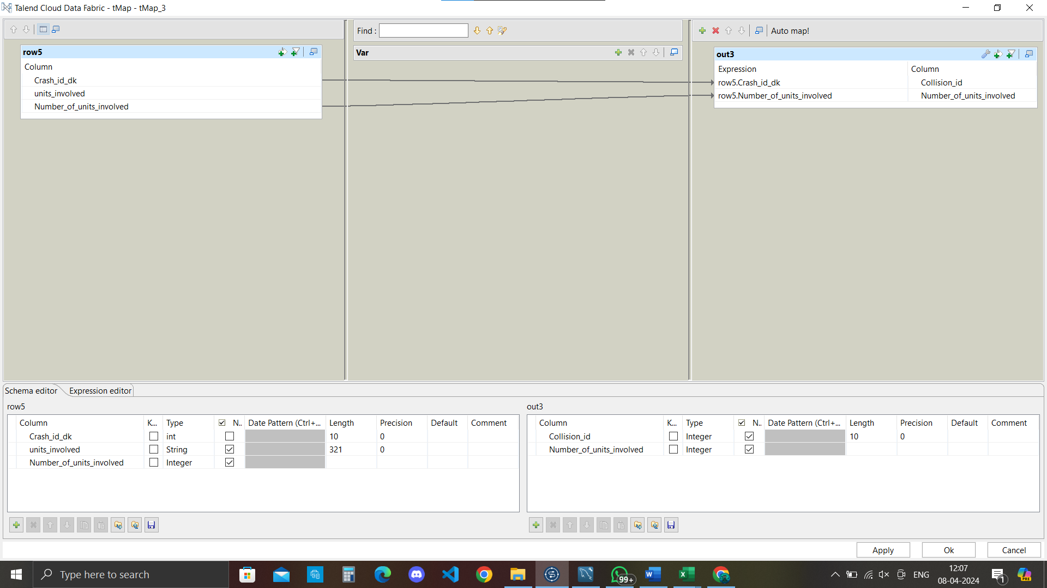

Here we have taken the crash id and number of units involved, this will help while loading the fact table.

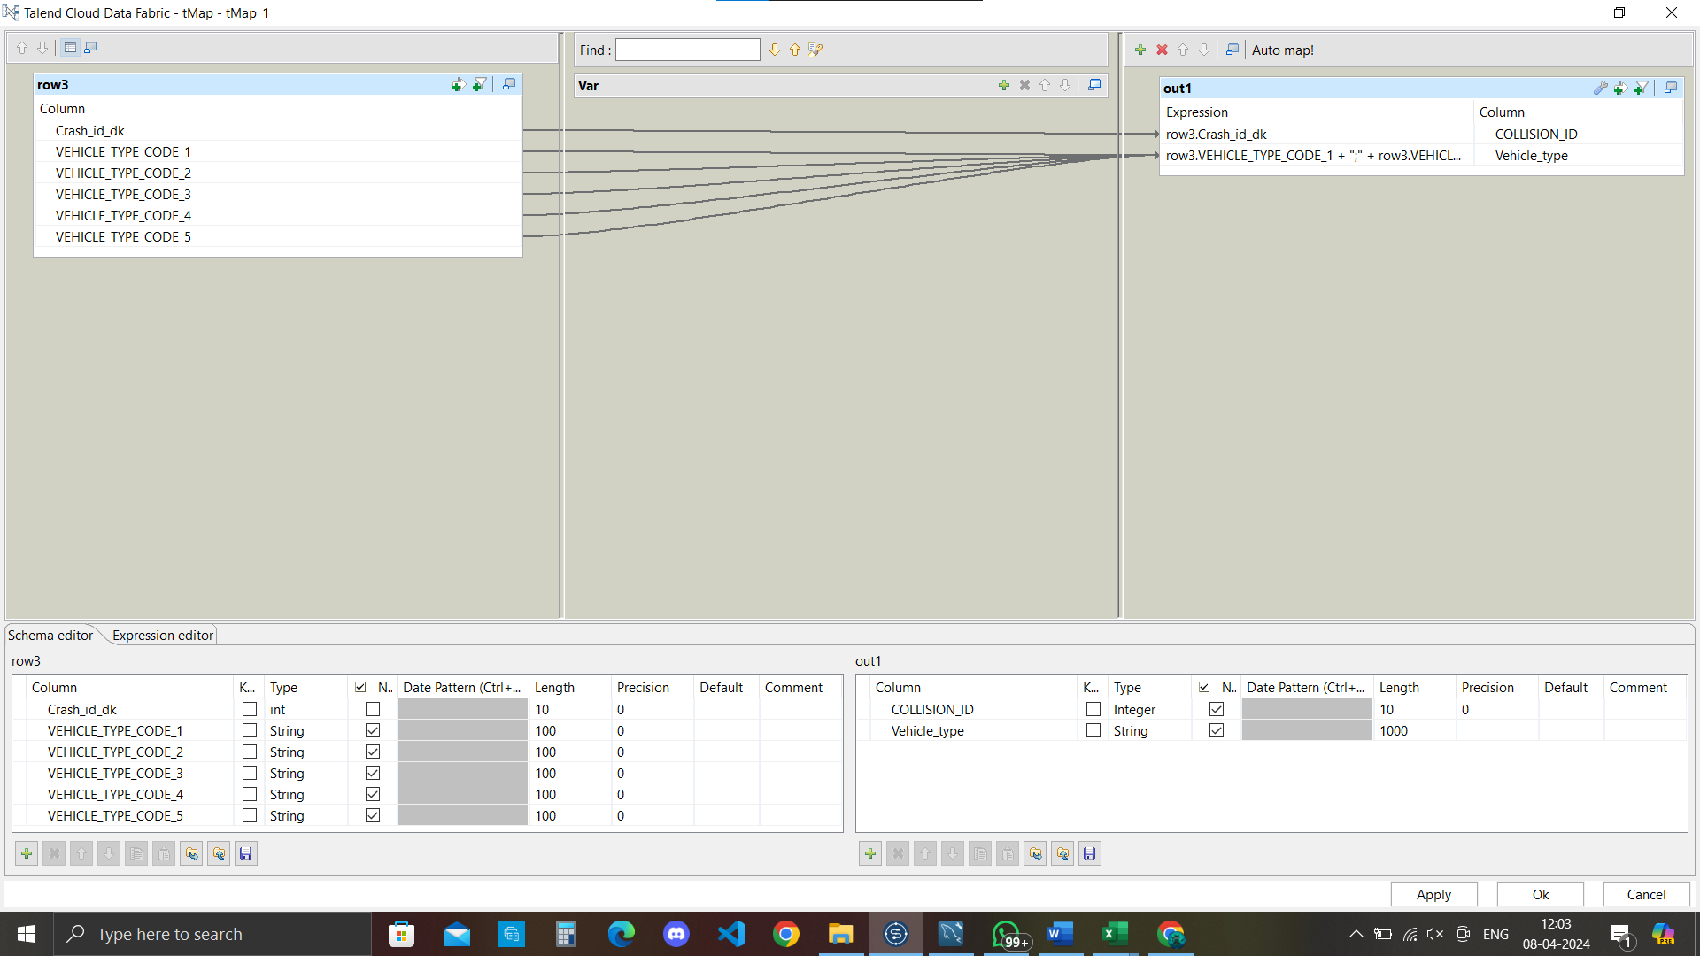

The above tmap configuration is for New York where we take all the vehicle code type and combine it to store it under vehicle type.   
Going ahead we normalize it using tnormalizer on the column vehicle type and item separator as “;” then we further use taggregate row to groupby on the collision ID.

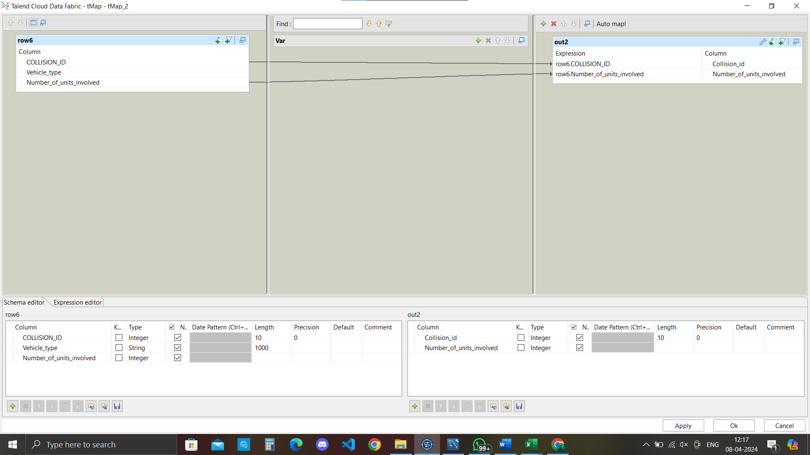

After aggregation we map it with the above tmap configuration.

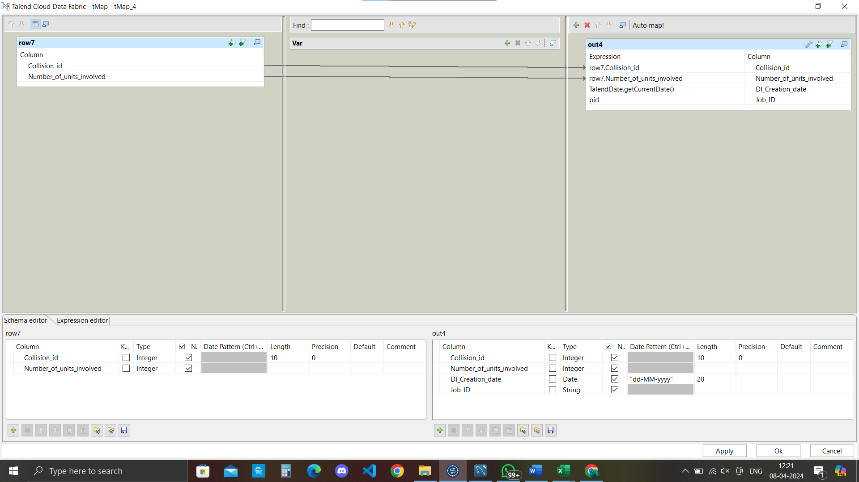

Then we unit it and map it with the above tmap configuration for connecting collision id and number of units involved.

**Vehicle_type_dim**

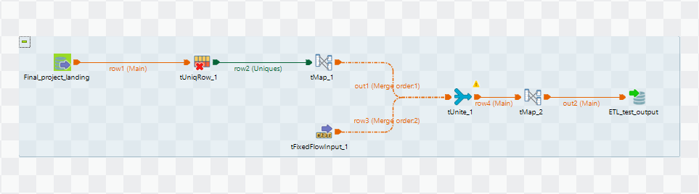

The above is the workflow for the vehicle type dimension.We have taken the above db input from the landing table that we had just created. Then we used tunique row to get distinct rows and then mapped it with the following tmap configuration:

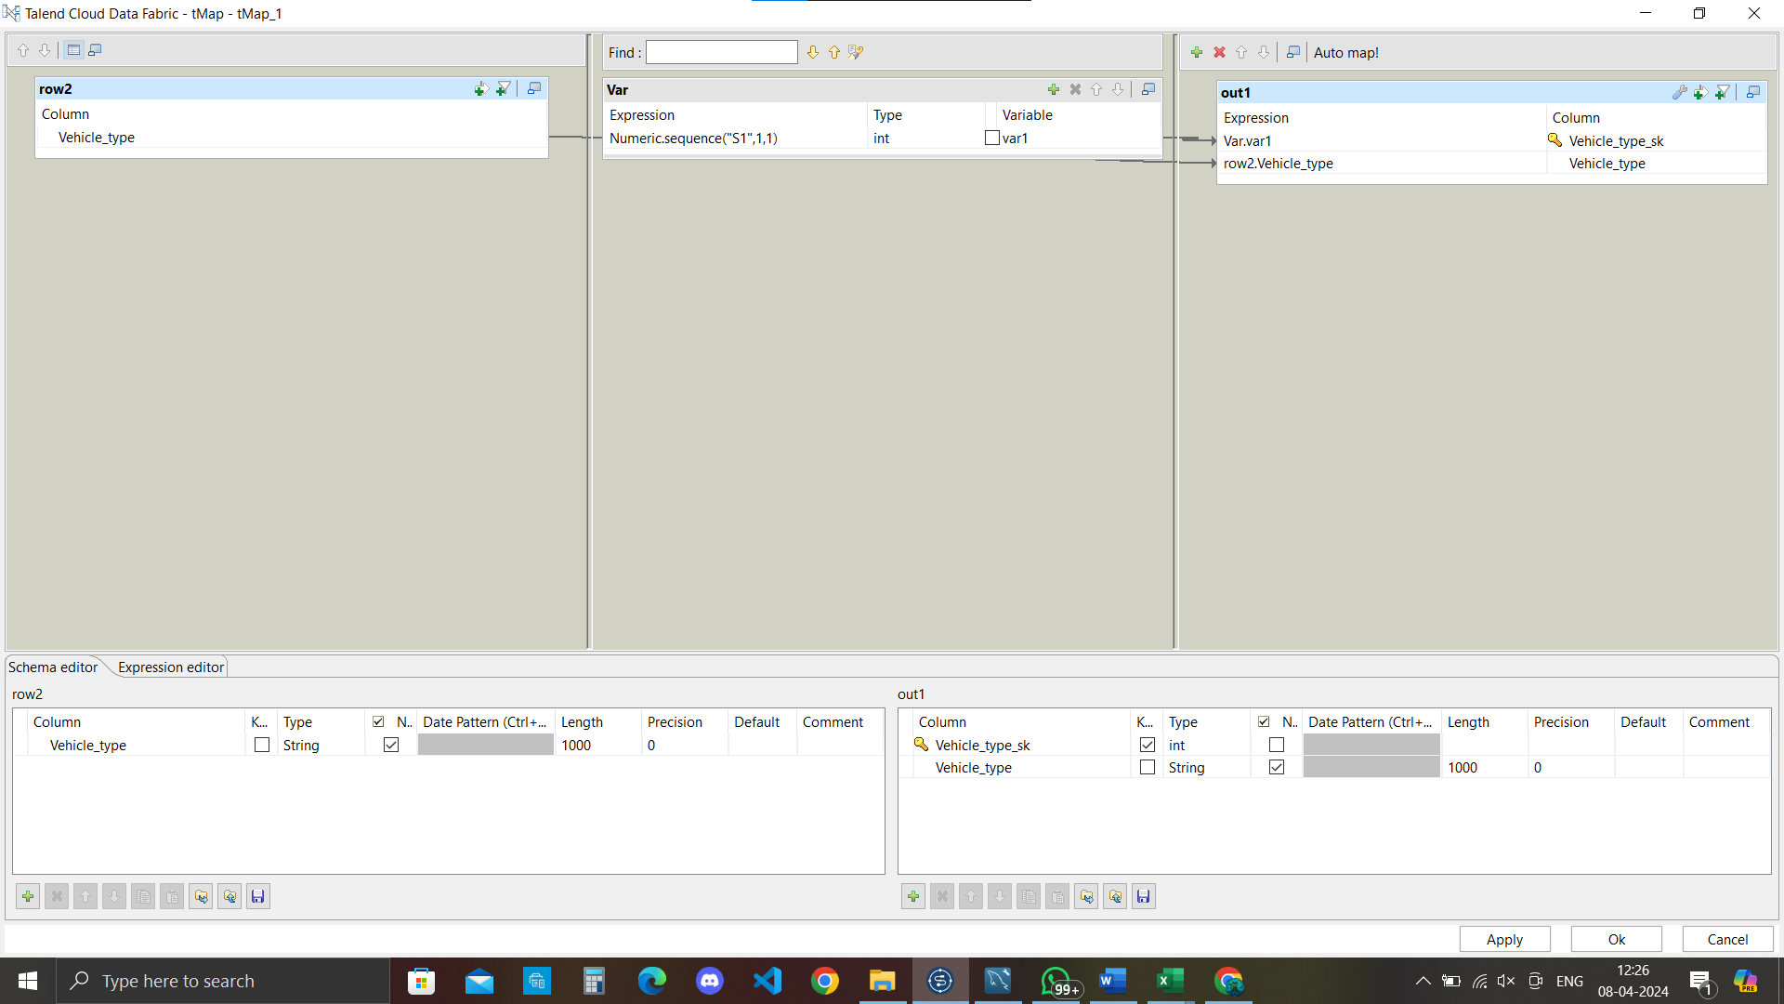

Here we created Vehicle Sk as a numeric sequence. Then used tfixedrow input to append a row which has not given for Vehicle_type and -1 for Vehicle_typeSK, this is done to match with the all null row.

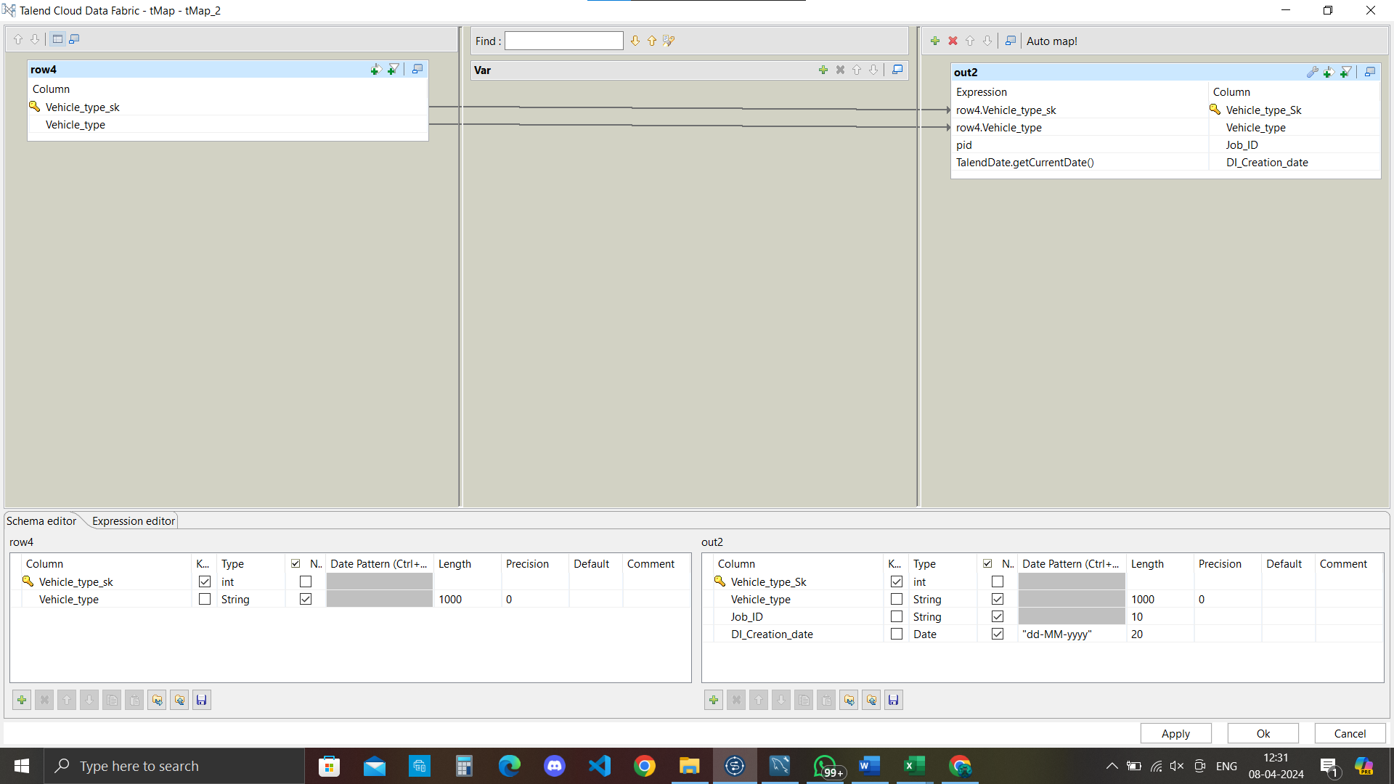

After merging with tunite we map it with the above tmap configuration.

**Crash Fact**

**Workflow**

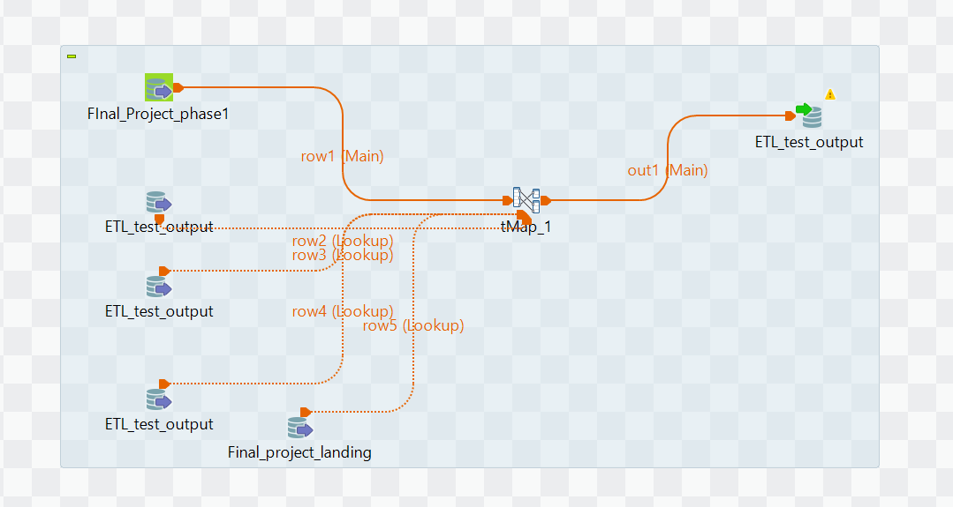

Here we are taking inputs from all the dimensions and the New York stage table.

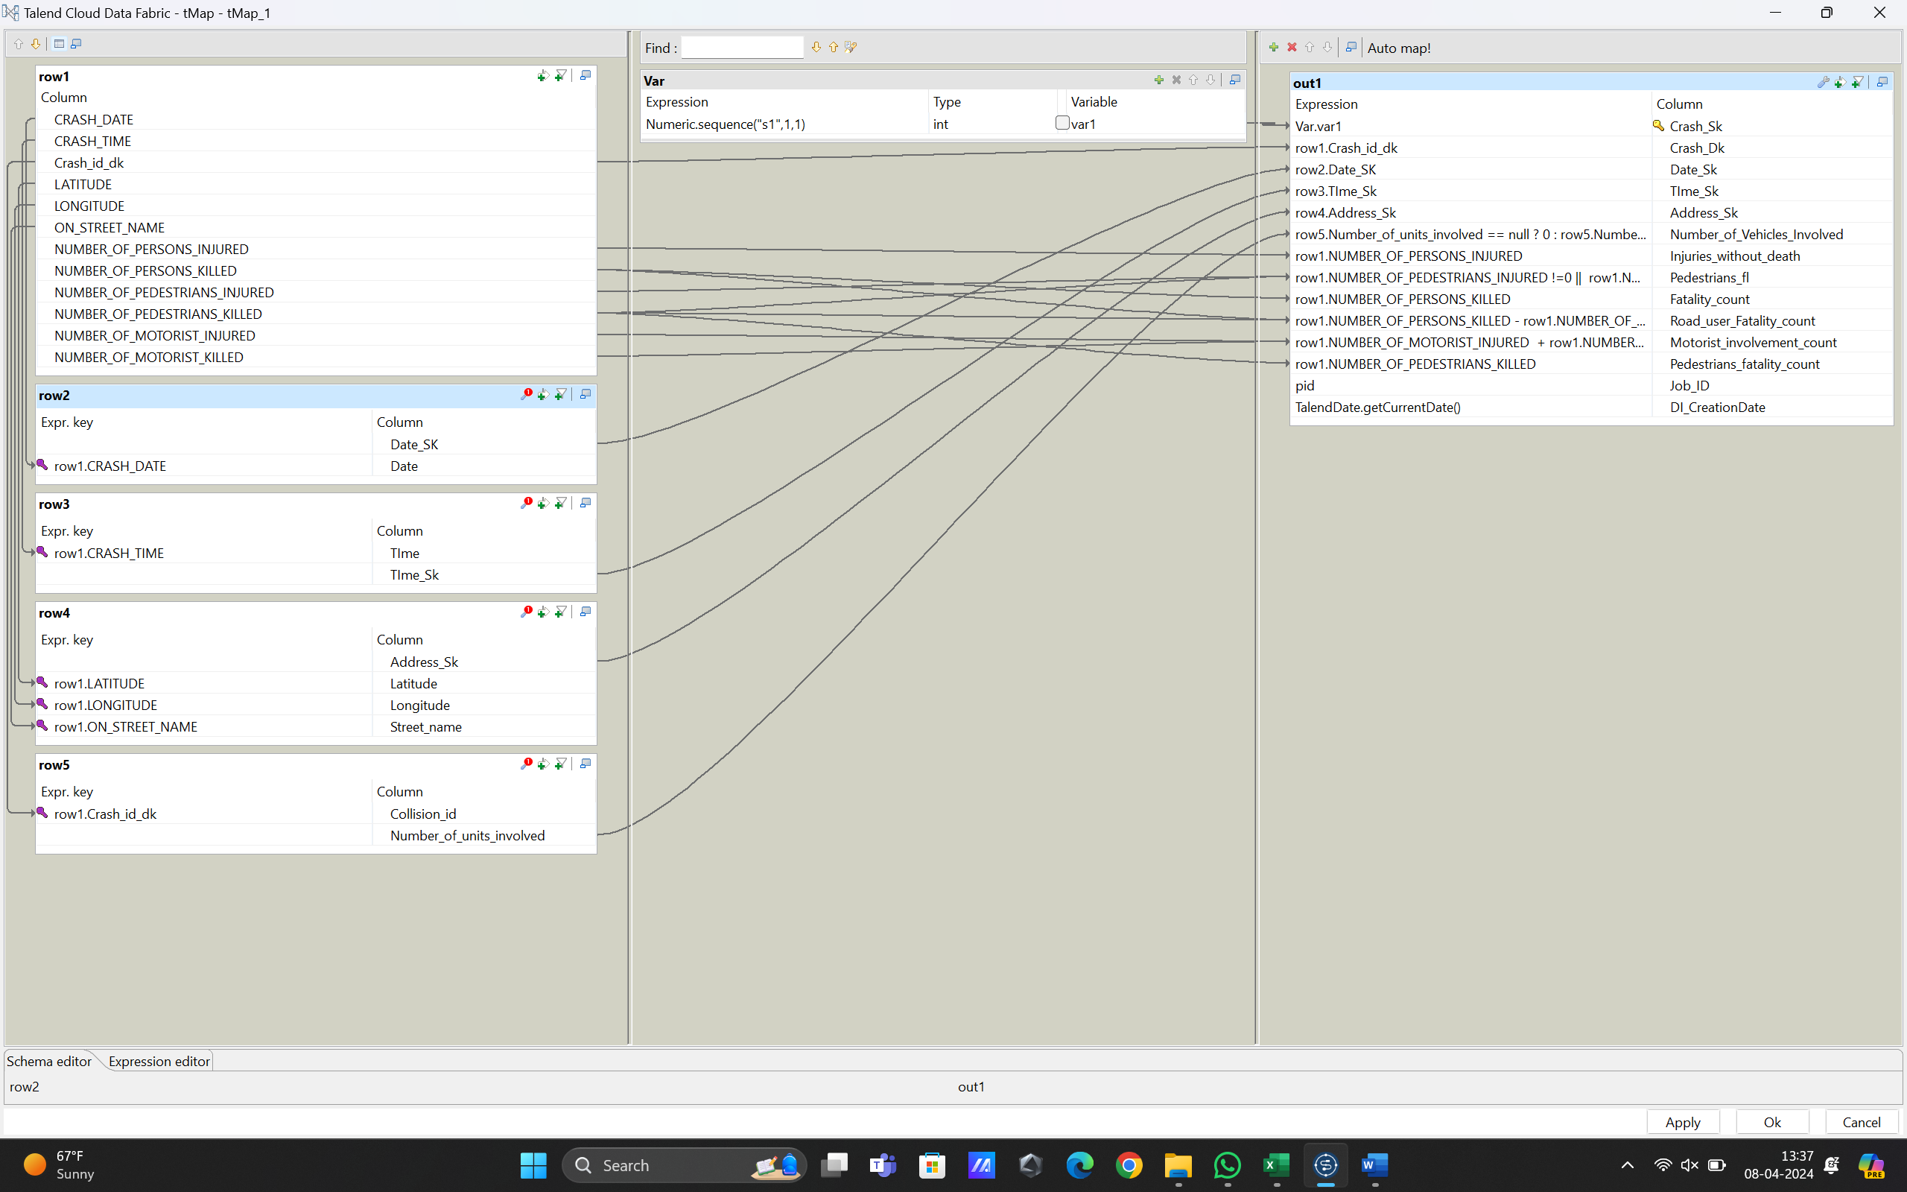

The above is the tmap configuration where we are doing left joins from the main table to the dimension tables to connect those with the main stage table. Then mapping out the required columns. We derived number of vehicles involved, injuries without death, fatality count road user fatality count, motorist involvement count and pedestrians fatality count.  
  
**Vehicle Dim  
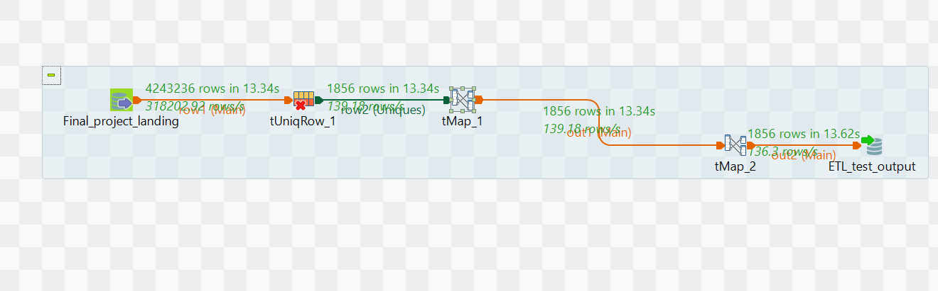**

Here we have use the vehicle type landing table which is followed by tunique row component which is mapped with tmap and the following is the tmap configuration  
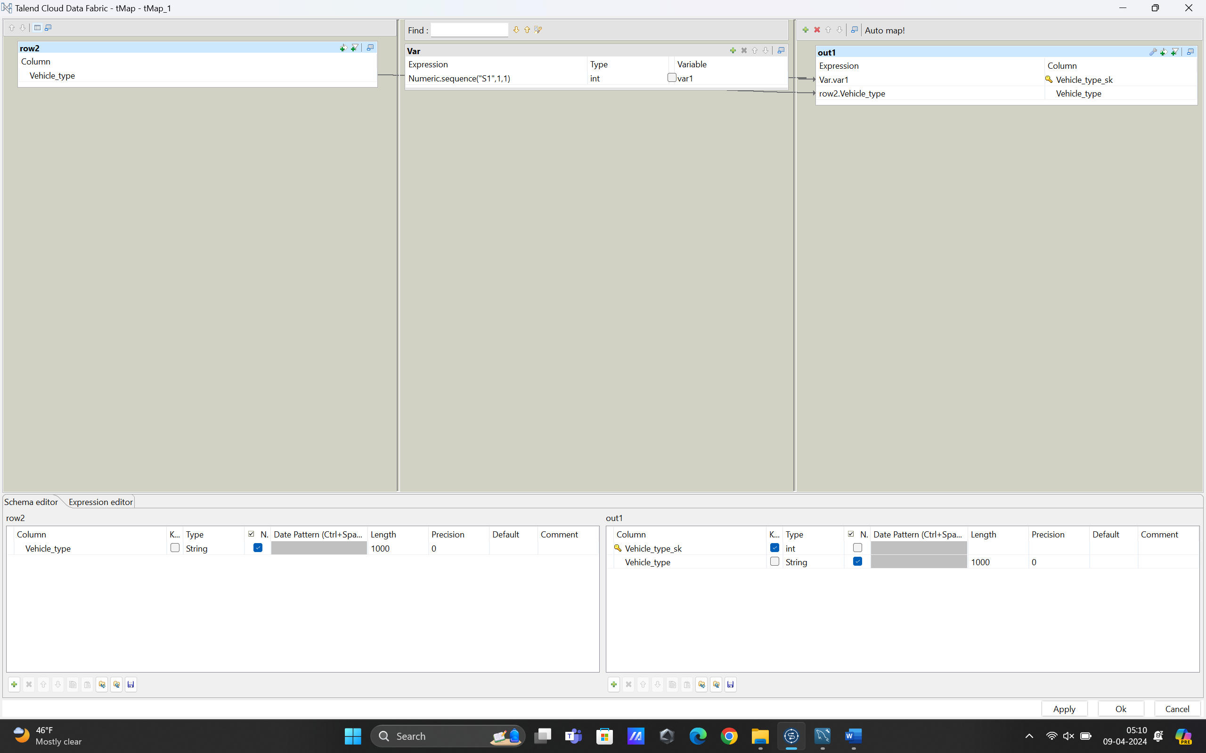

Here we generate a Vehicle_type surrogate key where we use a numeric sequence expression. The following tmap is of having the following configuration  
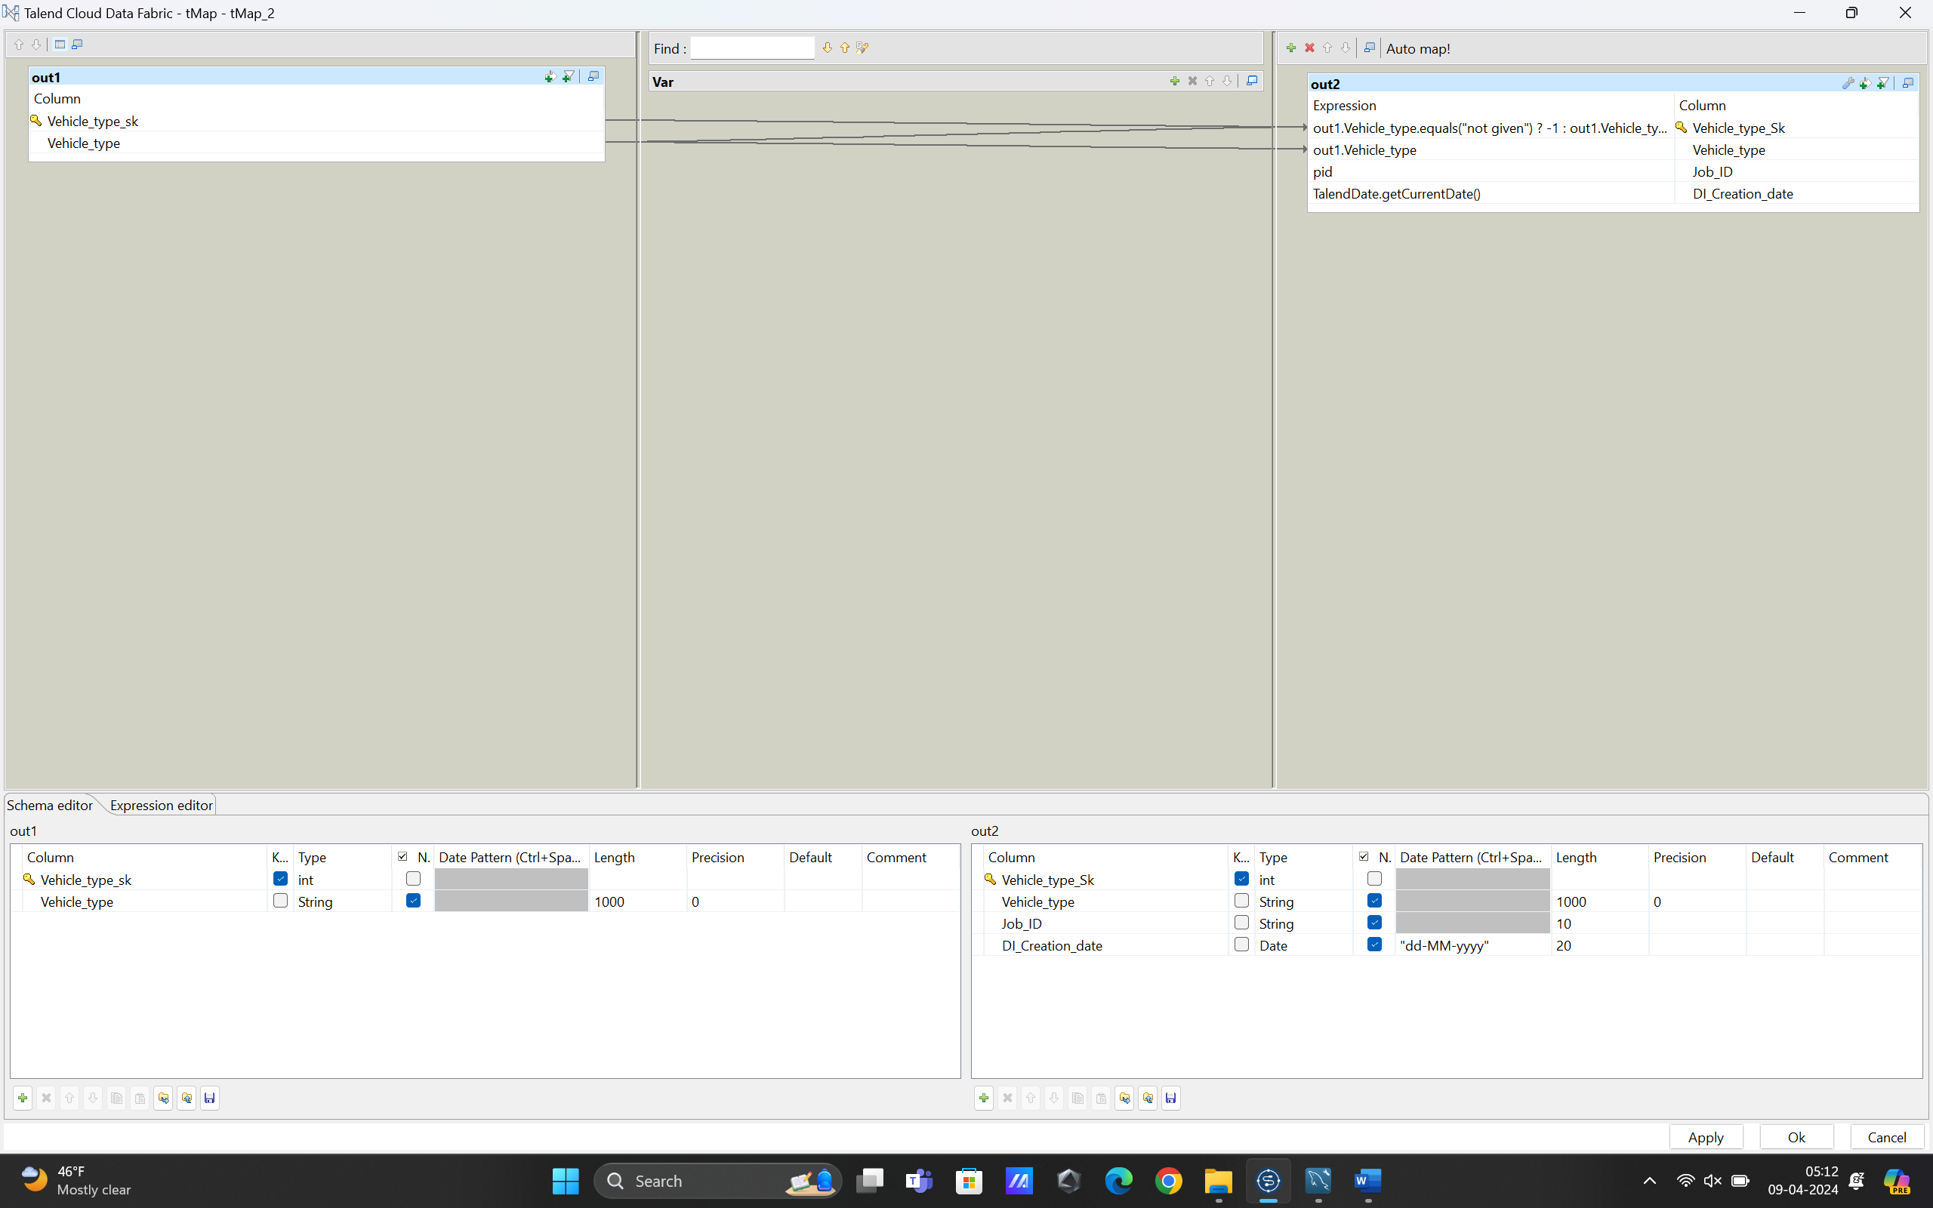here we have used the transformation that where every vehicle type is equal to not given give the vehicle type SK as -1.

**Crash_Fact**

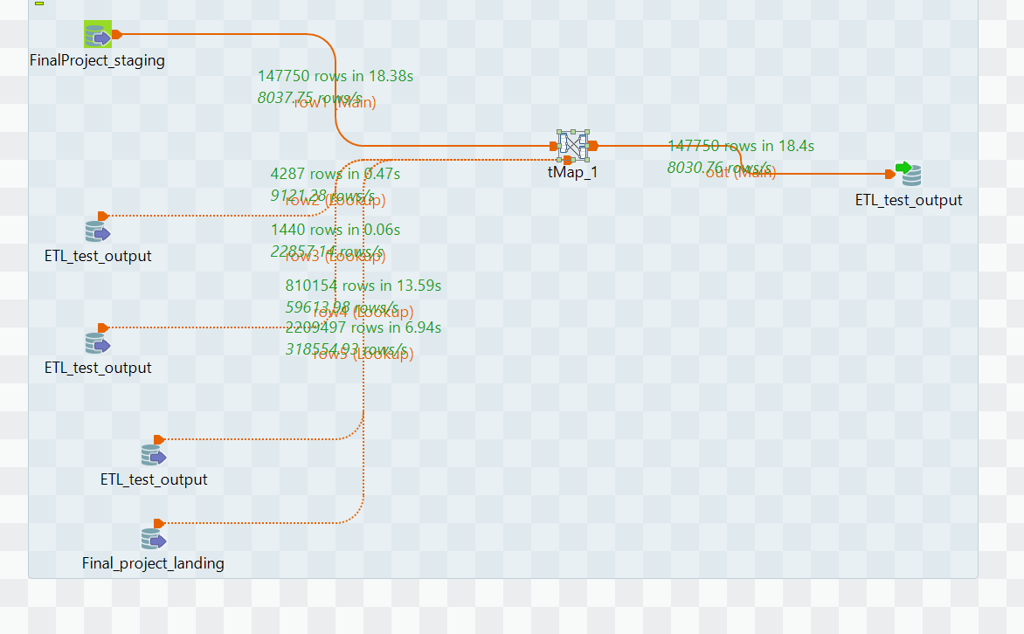  
the above is the workflow for loading the crash fact table. Here we have taken the stage table along with other dimensions to load the crash fact from

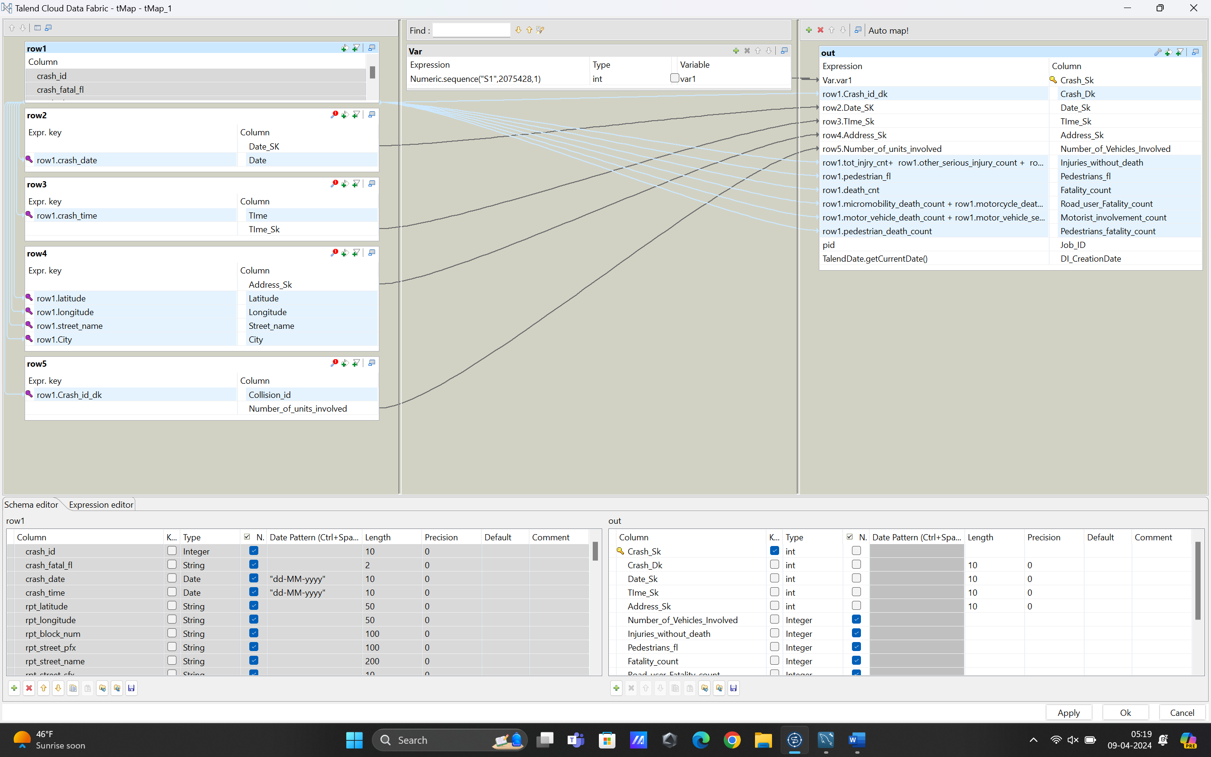

Here we have taken left join for each table and joined the dimensions together and mapped as the above tmap configuration.

**Factor_Fact**

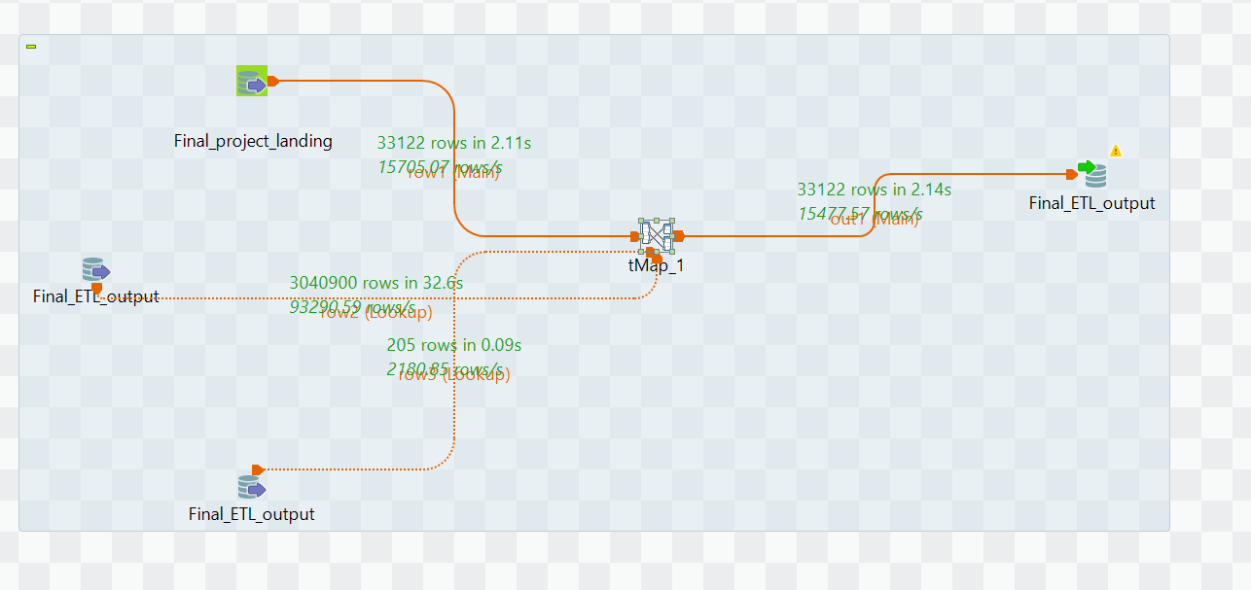

The above workflow is for factor fact, here we have taken the landing table along with the main fact table and contributing factor dimension.

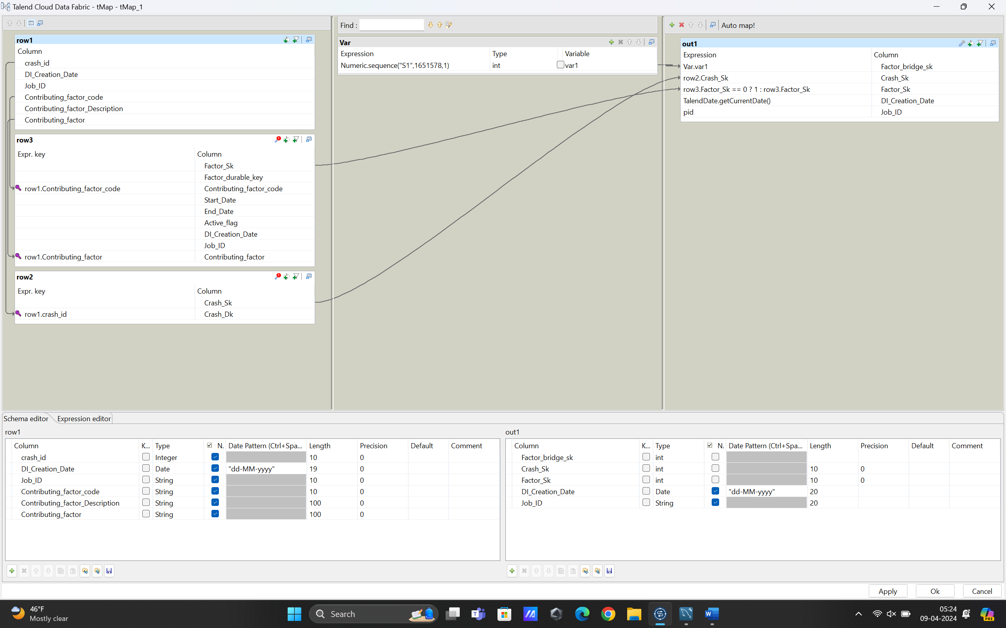  
the above is the tmap configuration where we take a inner join and join the tables to get the map the crash_id , contributing factor code and crash_dk.

**Address_dim**

**SELECT * FROM final_project_etl.address_dim;**  
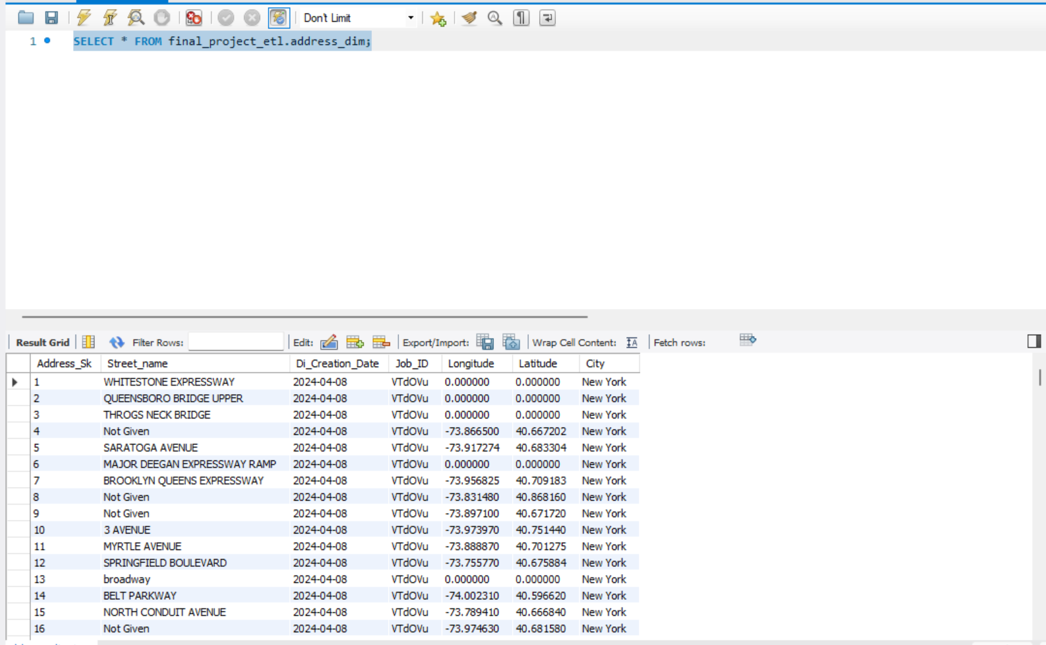

SELECT count(*) FROM final_project_etl.address_dim;  
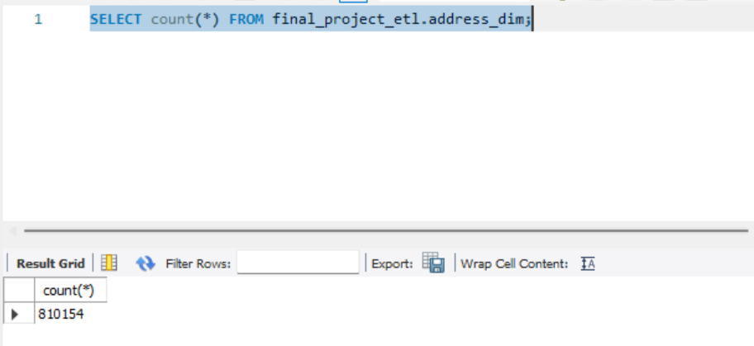

**Time Dim  
SELECT * FROM final_project_etl.time_dim;**  
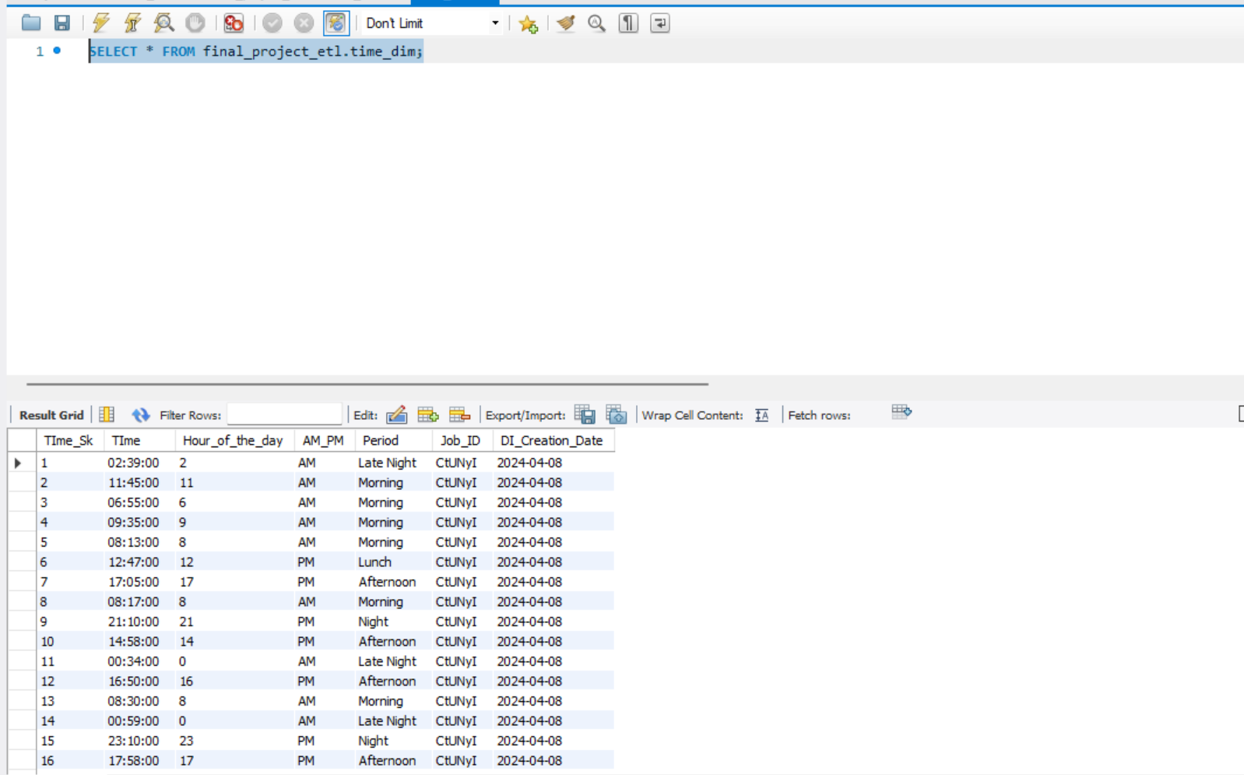

**SELECT count(*) FROM final_project_etl.time_dim;**  
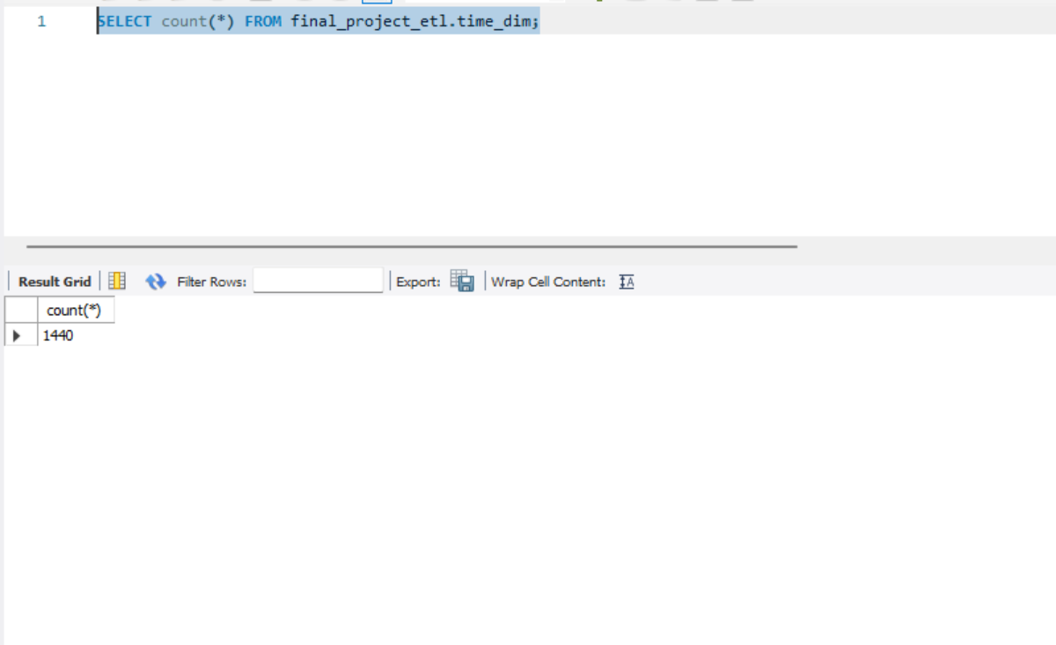

**Date Dim  
SELECT * FROM final_project_etl.date_dim;**

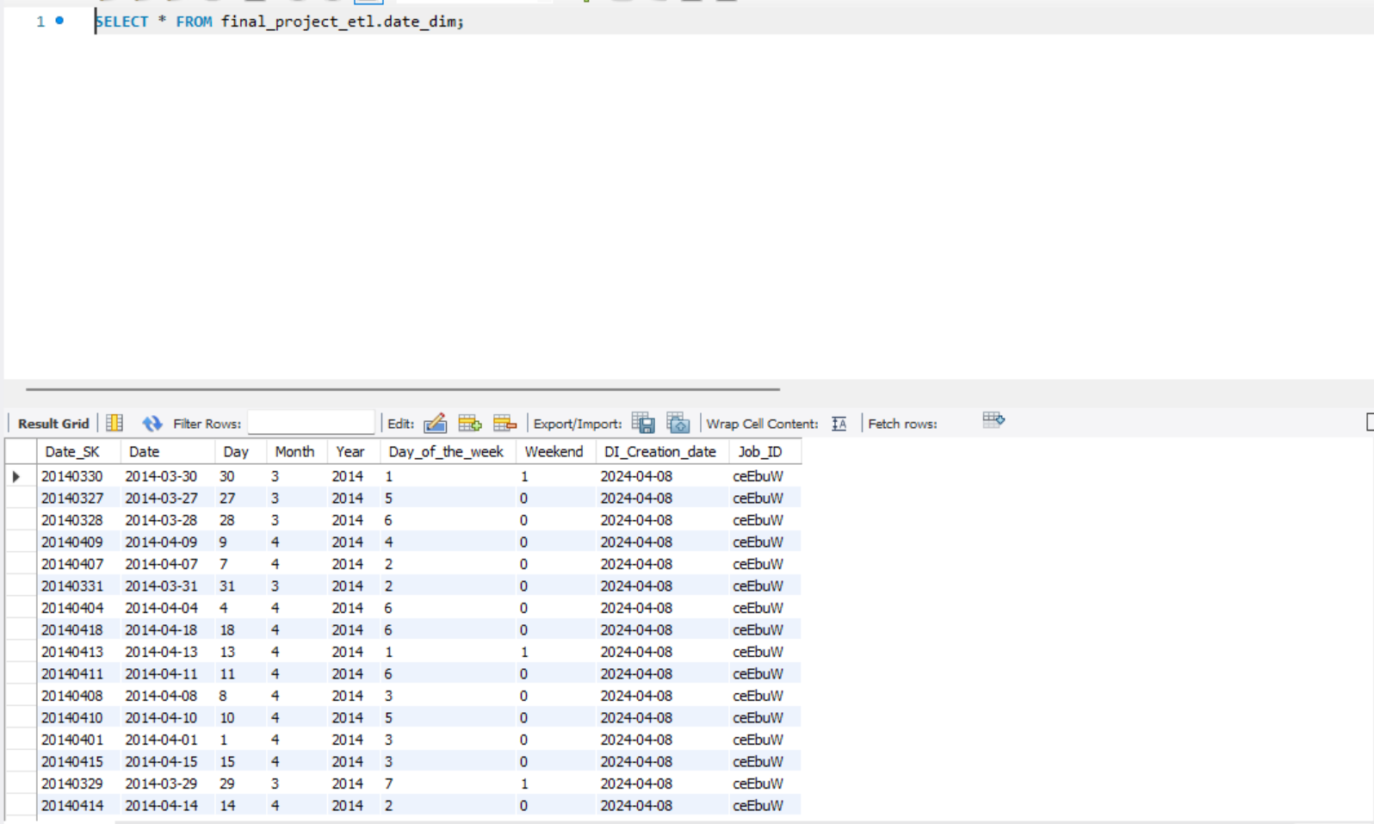

SELECT count(*) FROM final_project_etl.date_dim;

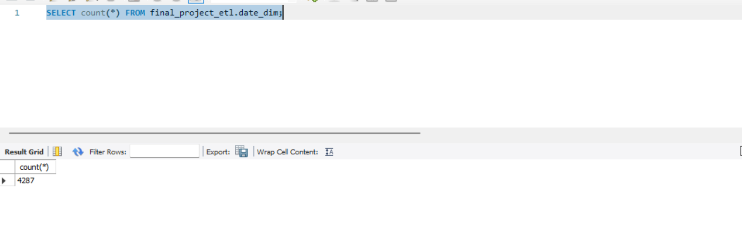

Vehicle Type dim  
SELECT * FROM final_project_etl.vehicle_type_dim;  
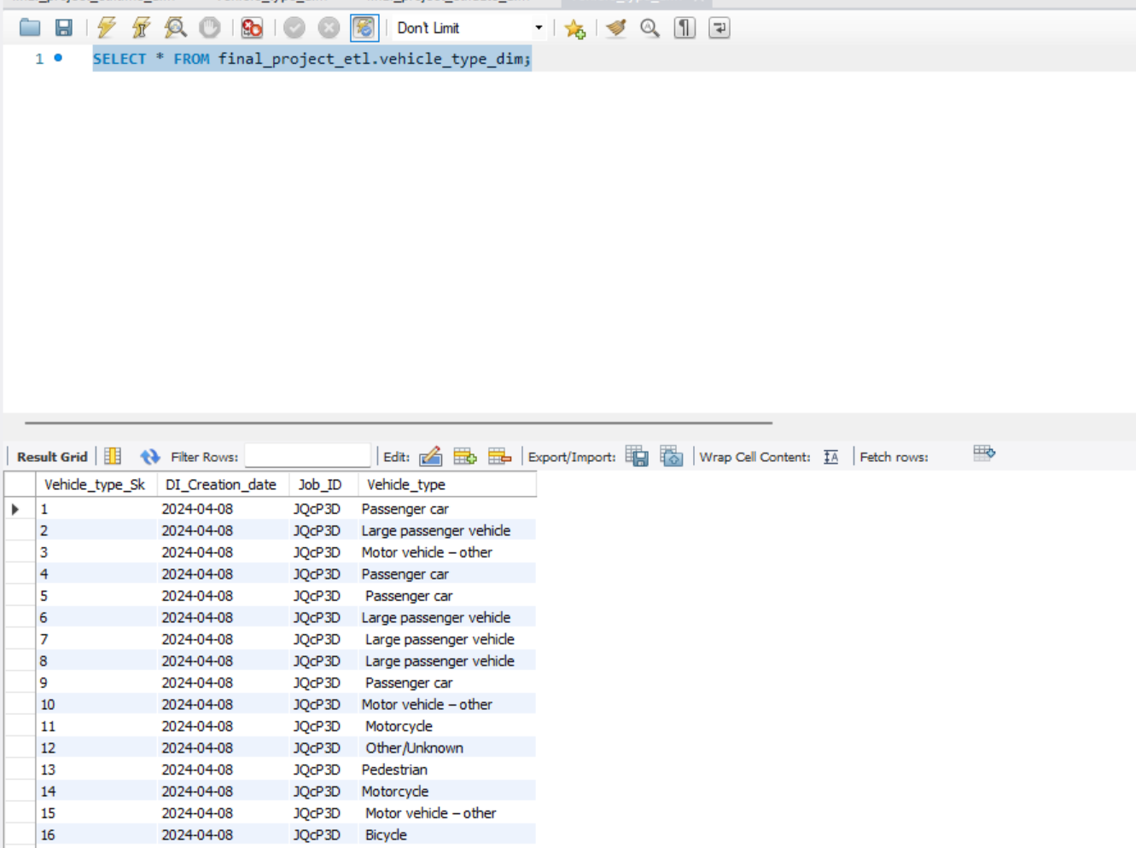

SELECT count(*) FROM final_project_etl.vehicle_type_dim;

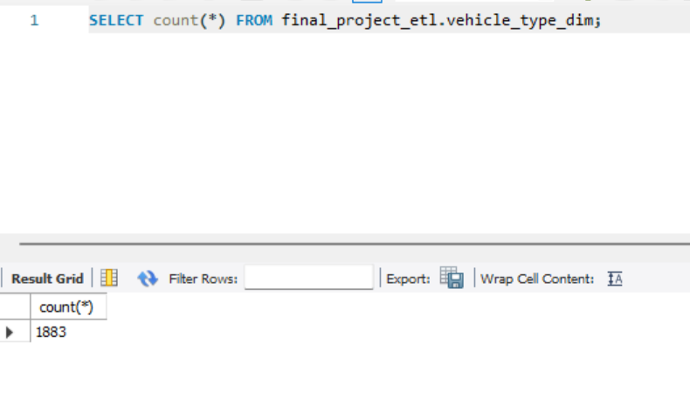

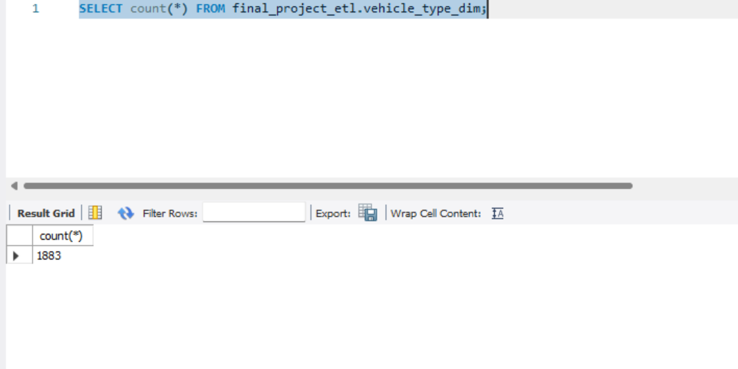

New York Stage table  
SELECT * FROM staging_tables.new_york_stg;  
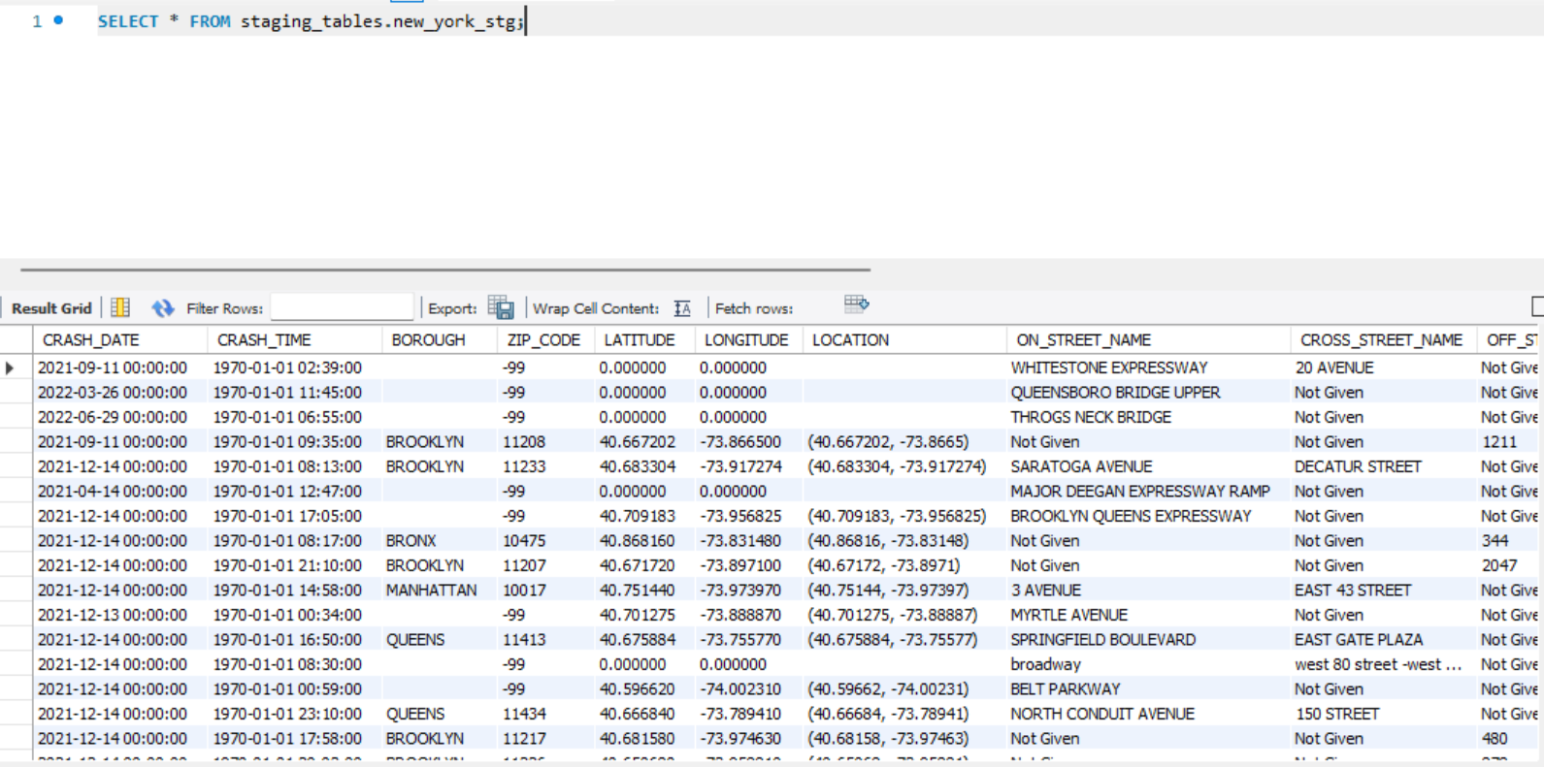

SELECT count(*) FROM staging_tables.new_york_stg;

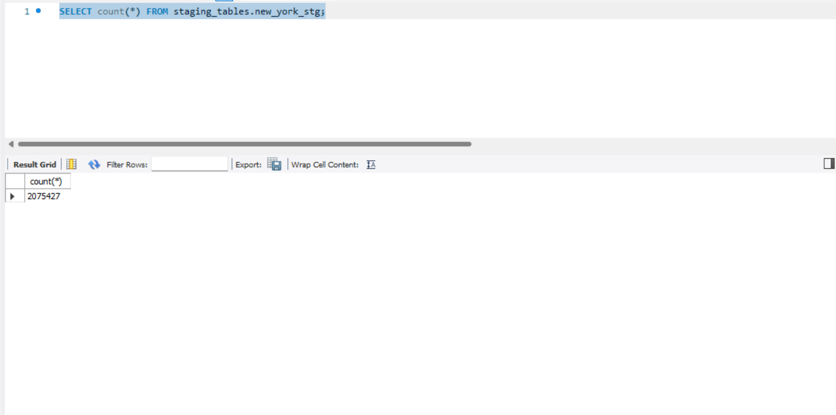

Chicago Stage  
SELECT * FROM staging_tables.chicago_stg;

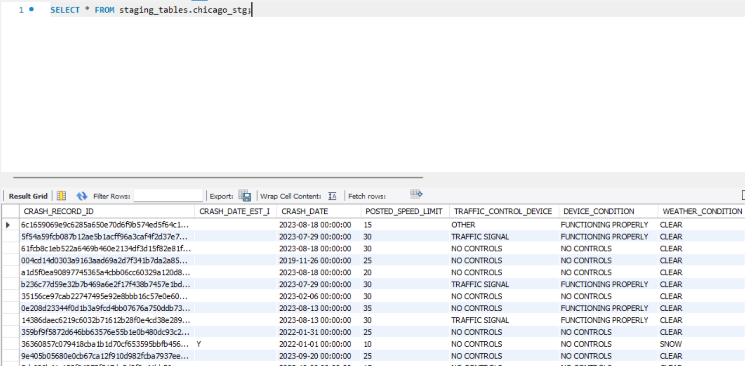

SELECT count(*) FROM staging_tables.chicago_stg;  
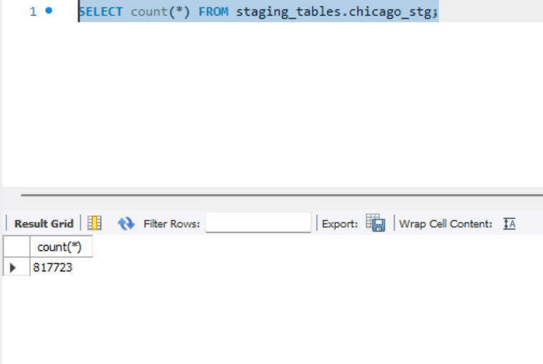

Austin Stage  
SELECT * FROM staging_tables.austin_stg;  
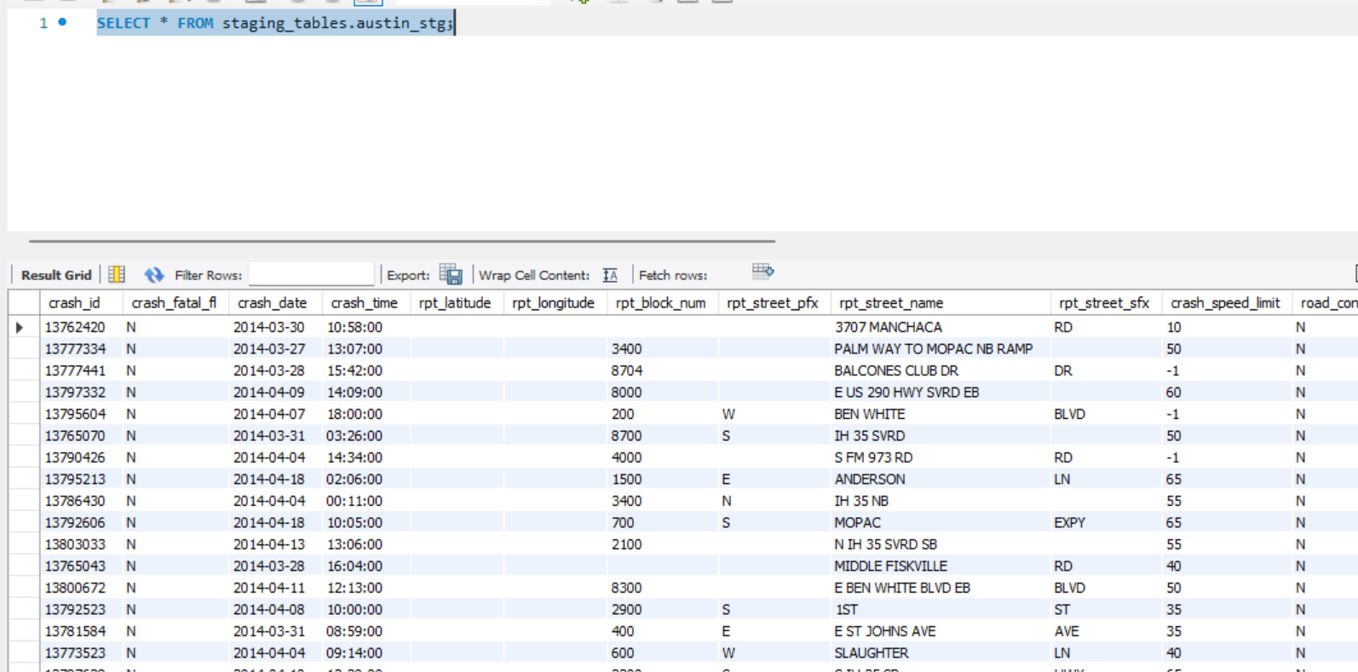

SELECT count(*) FROM staging_tables.austin_stg;  
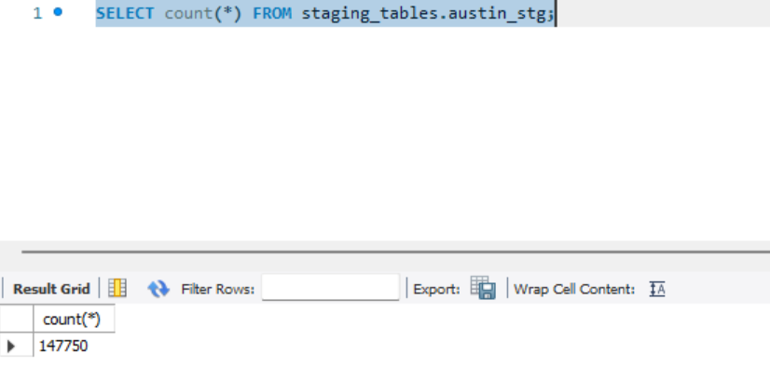

**Austin Landing   
SELECT * FROM final_project_landing.austin_landing;**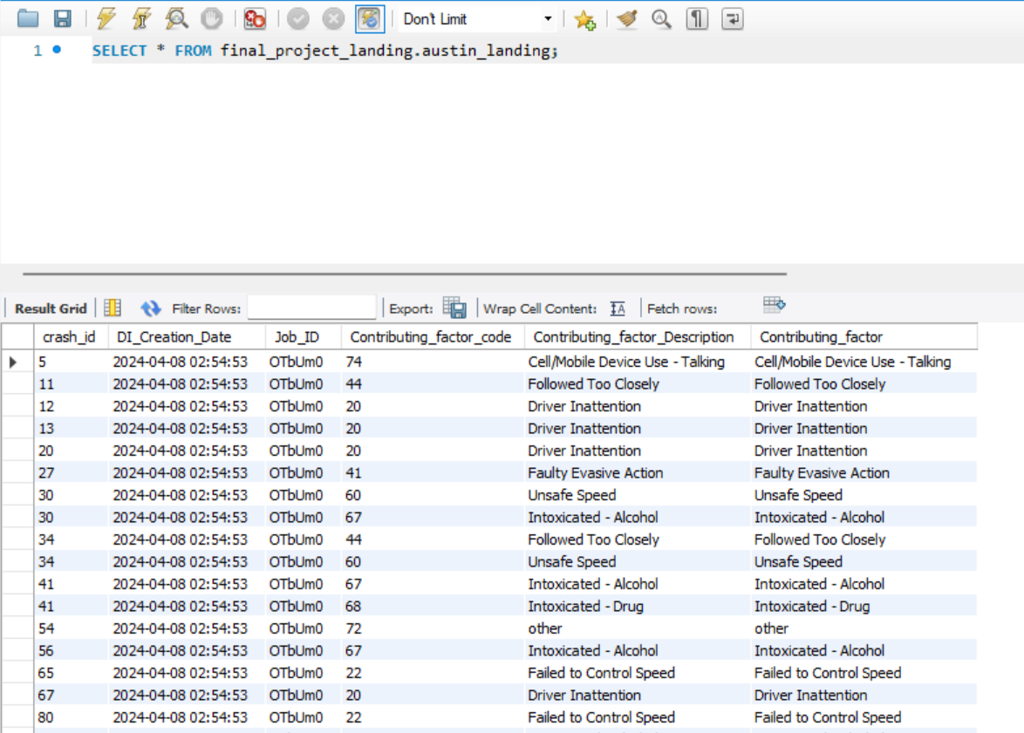

**SELECT count(*) FROM final_project_landing.austin_landing;**  
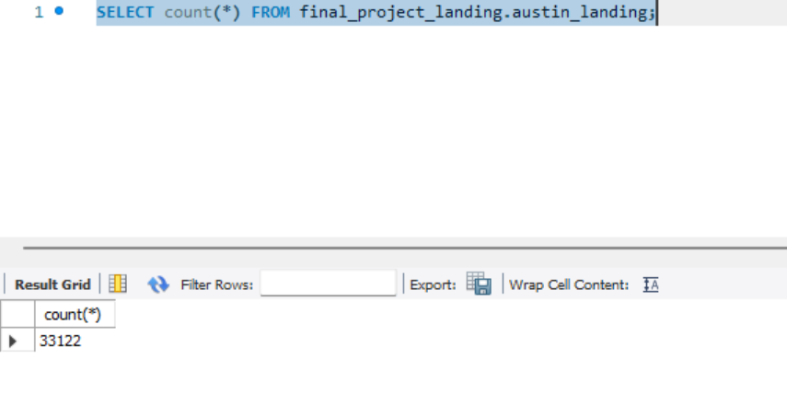

**Austin Landing Vehicle Type  
SELECT * FROM final_project_landing.austin_landing_vehicle_type;**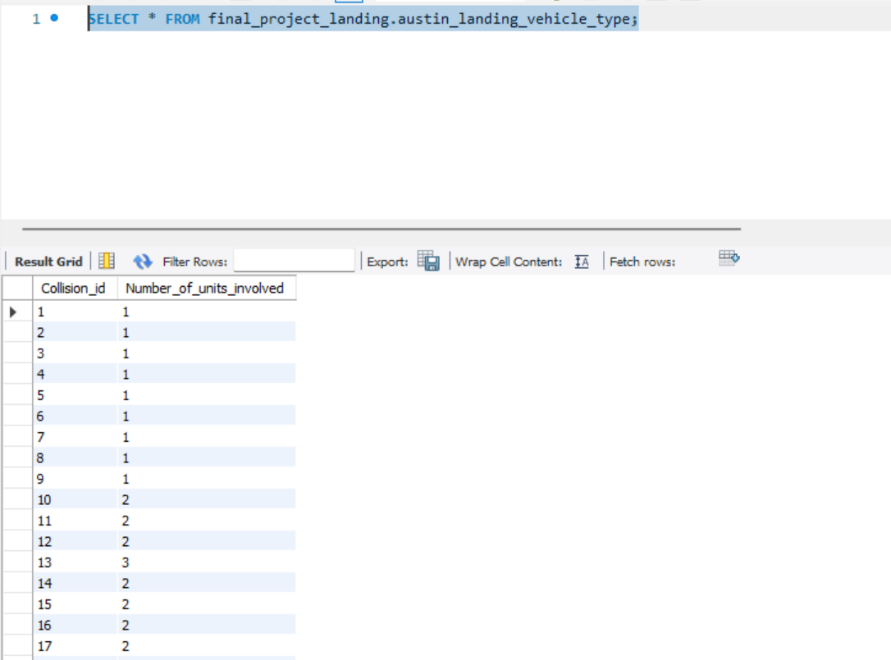  
**SELECT count(*) FROM final_project_landing.austin_landing_vehicle_type;**  
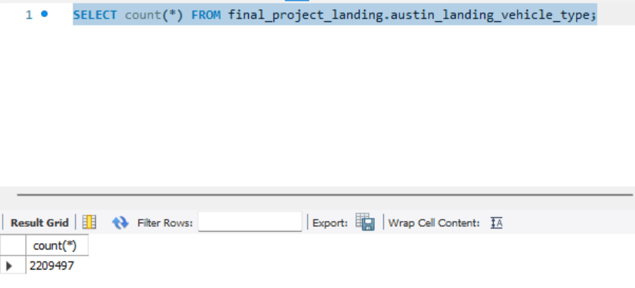**Chicago Landing  
SELECT * FROM final_project_landing.chicago_landing;**  
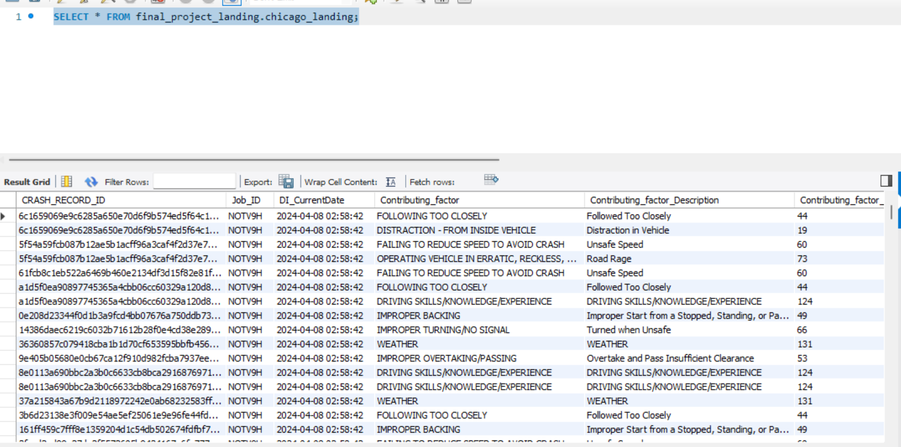 **SELECT count(*) FROM final_project_landing.chicago_landing;**  
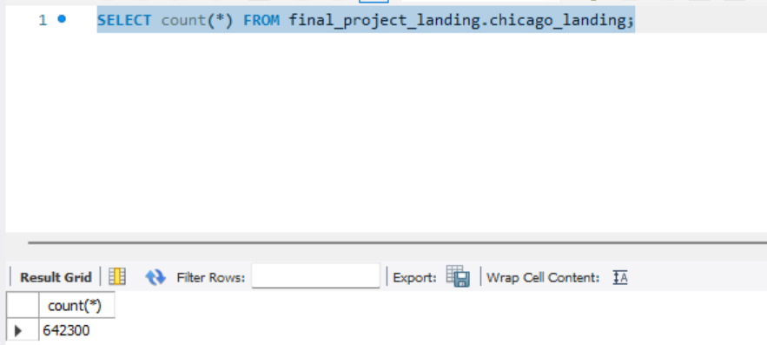

New York Landing

**SELECT * FROM final_project_landing.newyork_landing;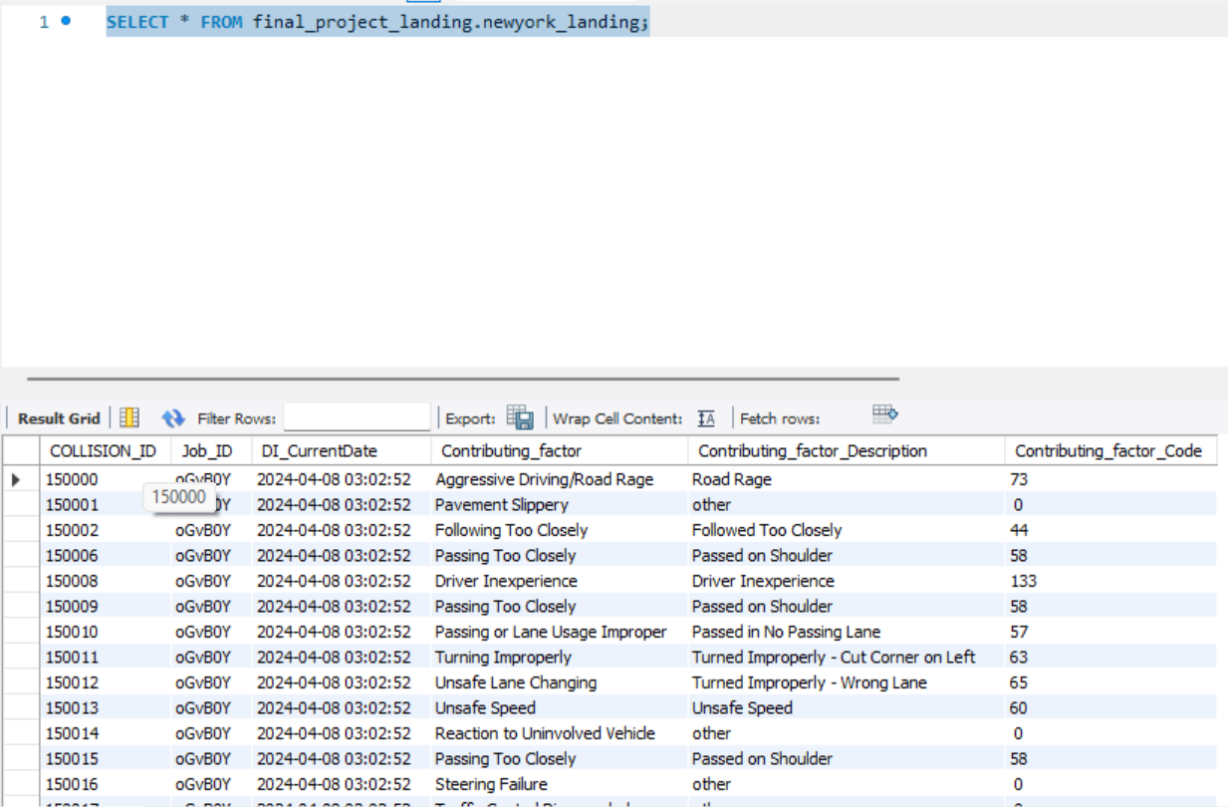 SELECT count(*) FROM final_project_landing.newyork_landing;**  
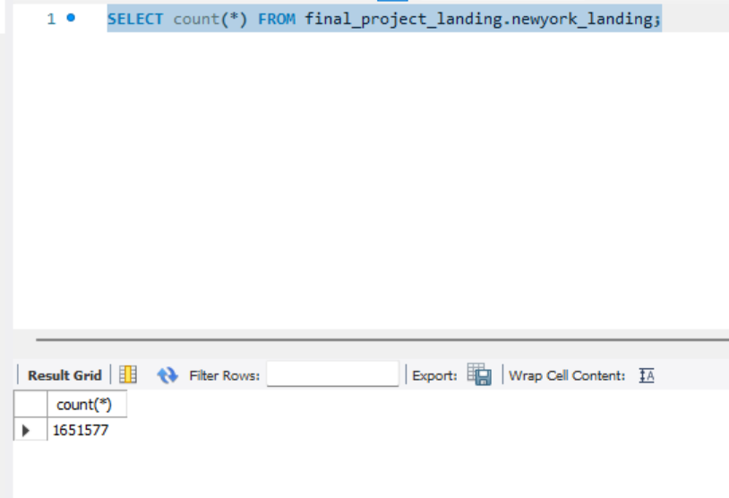

**Vehicle Landing table  
SELECT * FROM final_project_landing.vehicle_type_landing;**

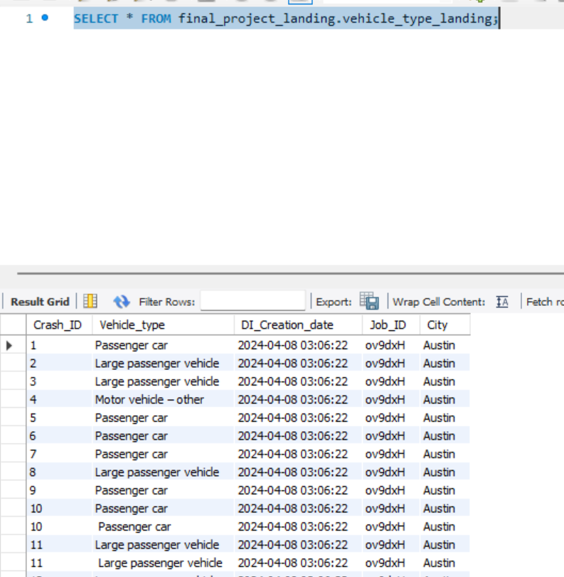

**SELECT count(*) FROM final_project_landing.vehicle_type_landing;**  
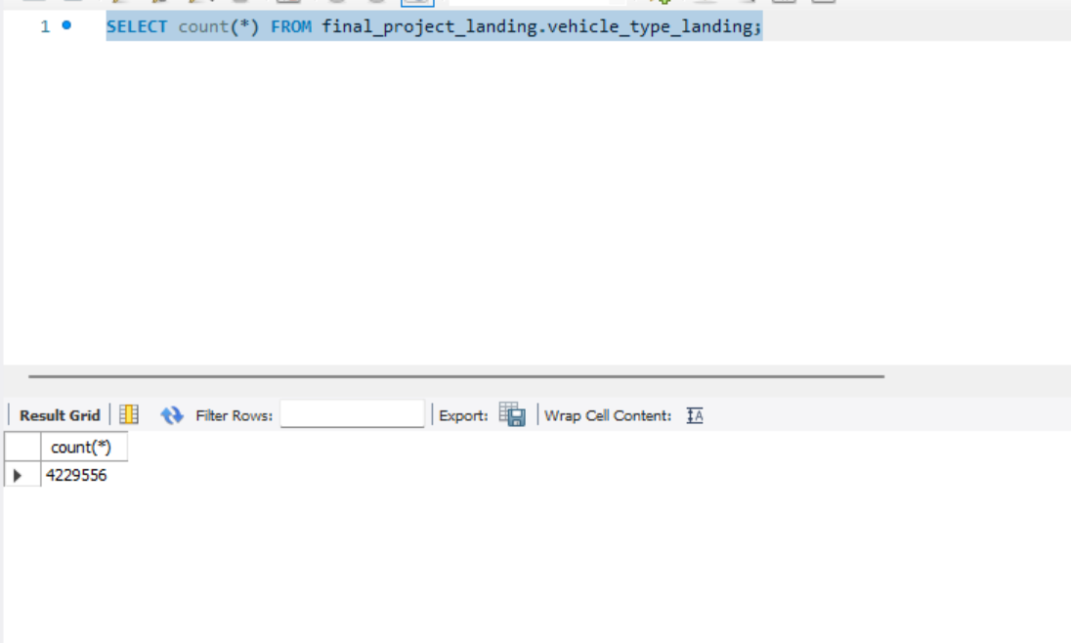

**Vehicle type dim  
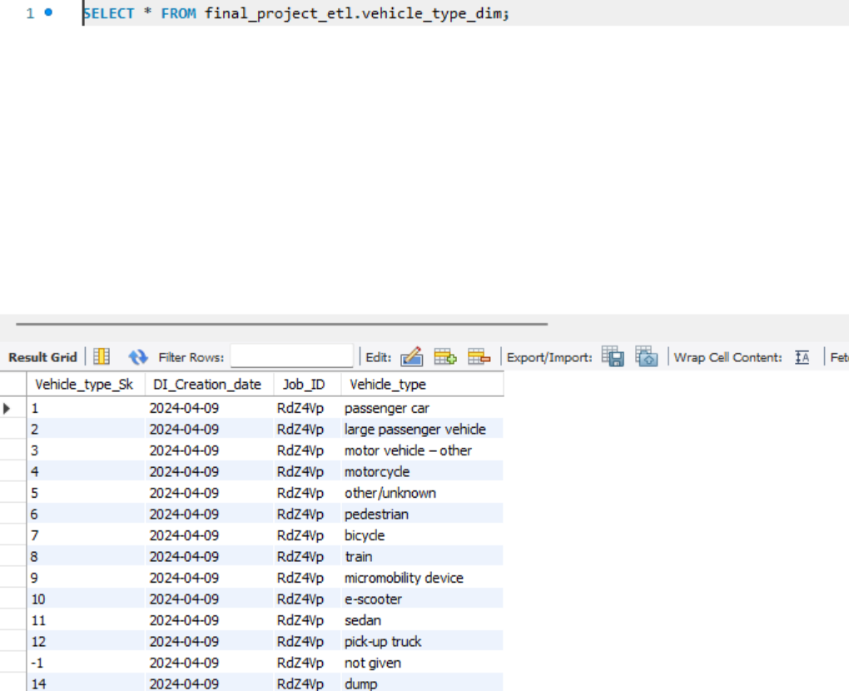**

**SELECT COUNT(*) FROM final_project_etl.vehicle_type_dim;**

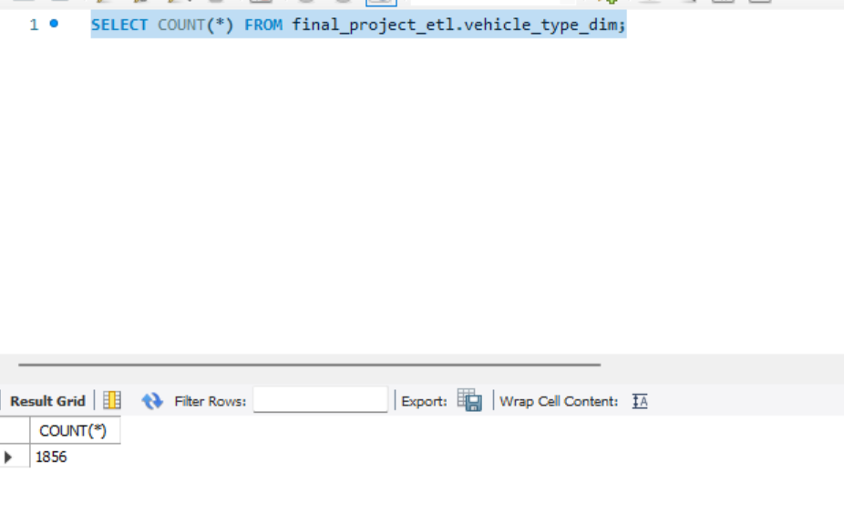

**Vehicle Fact table   
SELECT * FROM final_project_etl.vehicle_type_fact;  
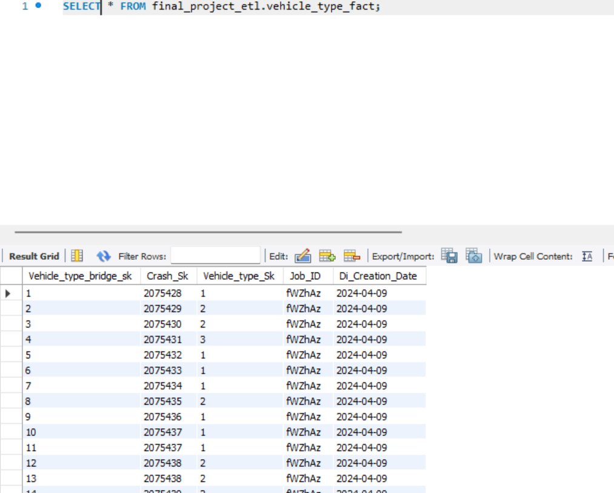**

**SELECT count(*) FROM final_project_etl.vehicle_type_fact;  
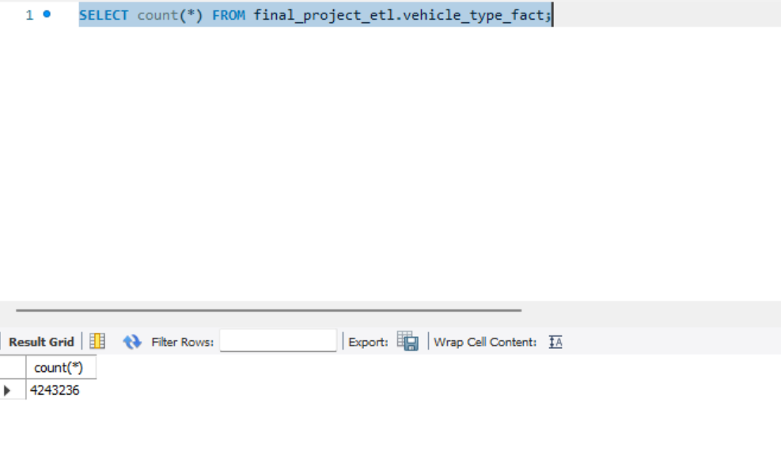  
Factor Fact Table  
SELECT * FROM final_project_etl.factor_fact;  
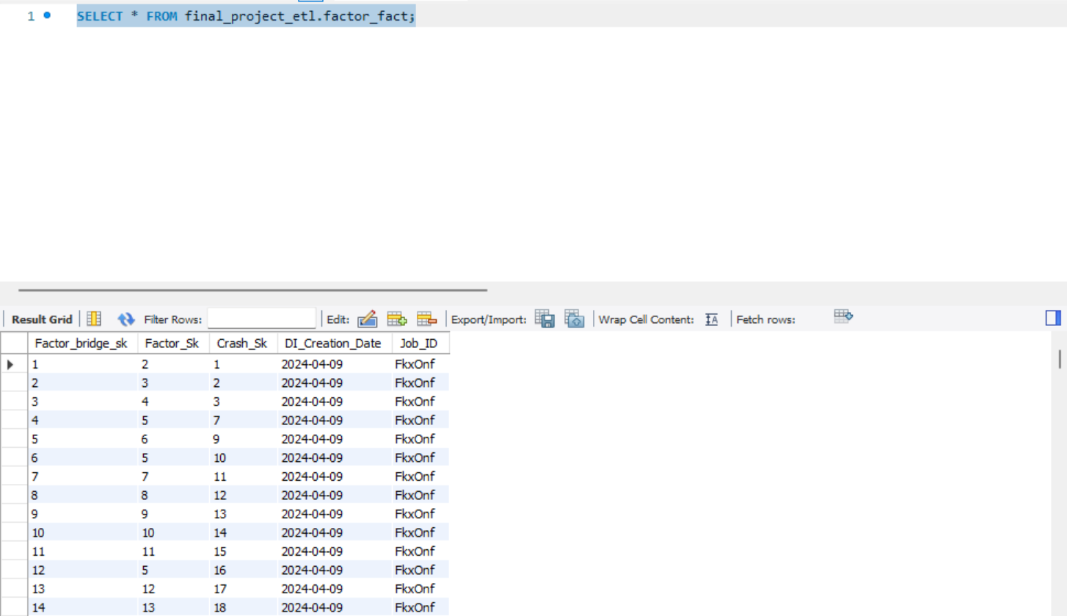**

**SELECT count(*) FROM final_project_etl.factor_fact;  
